

**S6 MATHEMATICS – 3 PERIODS**

**PART A**

**DATE:**  19th, December 2018

**DURATION OF THE EXAMINATION:** 45 minutes

**Total: 35 points**

**Non Calculator**



**NUMBER OF PUPILS: 9**

**EXERCISE 1-A:**

Differentiate the following functions.

a) $f\left(x\right)=-3x^{3}+6x^{2}-\frac{13}{\begin{aligned}217 \\ \end{aligned}}$ $\left[2\right]$

b) $g\left(x\right)=\frac{1}{2}x^{4}-\frac{1}{3}x^{3}$ $\left[2\right]$

**EXERCISE 2-A:**

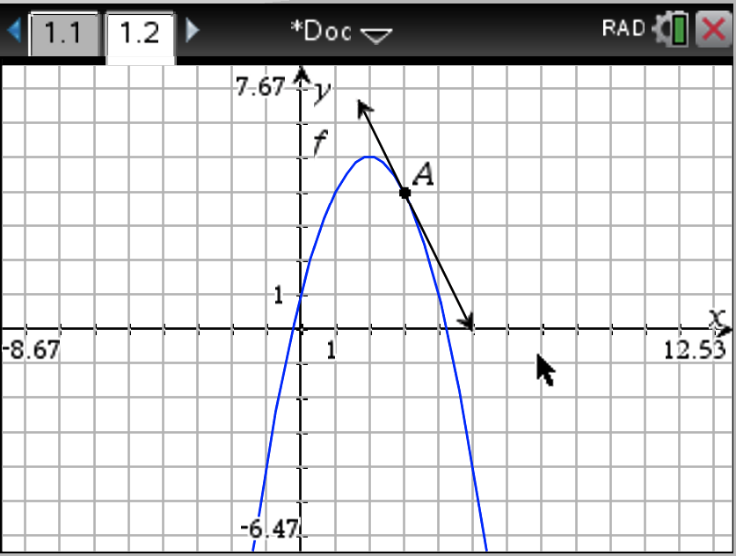

The figure shows the graph of function $f$.

1. From the graph find the values of $f\left(0\right), f\left(2\right) and f\left(3\right).$ $\left[3\right]$

1. From the graph find the values of $f’(2) and f’(3)$ $\left[4\right]$
2. Write the equation of the tangent to the graph at point A. $\left[4\right]$
3. From the graph find the range of values for $x$ such that $f’(x) < 0$. $\left[4\right]$

**EXERCISE 3-A:**

Consider the function *f* (*x*) = $x^{2}-2x-8$ and its graph F.

1. Find the coordinates of the turning point of F. $\left[2\right]$
2. Write the equation of the tangent to F at $x=2$. $\left[4\right]$
3. Find the coordinates of the intersection point of F with the line $y=-x-2$. $\left[4\right]$

**EXERCICE 4-A: $\left[6\right]$**

|  |  |
| --- | --- |
| The figure on the right represents the graph of a derivate function $f’$.  Choose among the graphs below the one (s) that could represent the function $f$.  **You must justify your answer carefuly, otherwise no points will be awarded.** | Graph of function |

|  |  |
| --- | --- |
| Graph 1 | Graph 2 |
| Graph 3 | Graph 4 |
| Graph 5 | Graph 6 |