

**S6 MATHEMATICS – 3 Periods**

**PART B**

**DATE:**  19th, December 2018

**DURATION OF THE EXAMINATION:** 90 minutes

**Total: 65 points**

**With Calculator**

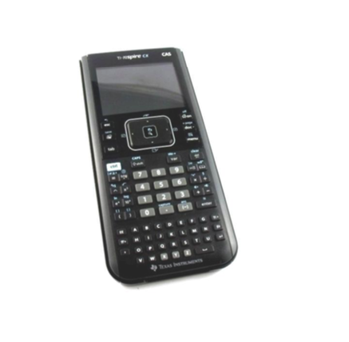

**NUMBER OF PUPILS: 9**

**INSTRUCTIONS: ANSWER QUESTION 6-B ON THE GRAPH PROVIDED**

**AND RETURN WITH OTHER ANSWER SHEETS**

**EXERCISE 1-B:**

The figure represents the graph of a derivate function $f’$ of a function $f$.

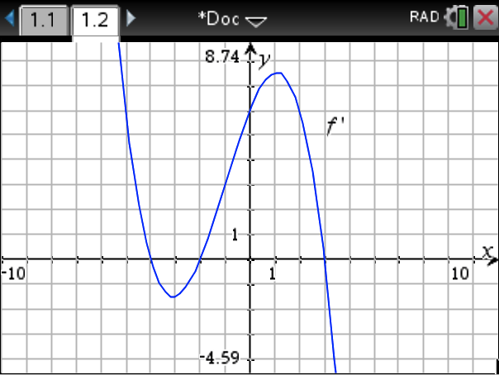

1. Give the $x$-coordinates of the extrema of $f$ and state their nature. $\left[6\right]$
2. From the graph of $f^{'}$ find the slope of the tangent to the graph of $f$ at $x=-1.$ $\left[2\right]$
3. Find the solutions for $f^{'}\left(x\right)=6.$ $\left[3\right]$
4. The graph of function $f$ passes through point $P(0, 1).$ Find the equation

of the tangent to the graph of $f$ at point $P$. $\left[4\right]$

**EXERCISE 2-B:**

Consider the function *f* (*x*) = ${-x}^{3}-3x^{2}+5x+7$ and its graph *F*.

1. Draw a table of signs showing the variations of function *f*. $\left[6\right]$
2. Find the coordinates of the turning points of *F* and state their nature. Give answers correct to 1 d.p. $\left[2\right]$
3. Find the equation of the tangent to the graph at $x=-1$. $\left[2\right]$
4. Find the coordinates of the points on *F* where the tangent has slope 5. $\left[2\right]$
5. Find the equation of the tangents to *F* with slope 5. $\left[2\right]$

**EXERCISE 3-B:**

A volleyball player serves from the back line of the court to send the ball into the adversary

camp. The height $h$ of the ball, in meters, is given by the following function :

$h\left(t\right)=-4.9t^{2}+3.8t+1.7$, where *t* is in seconds.

(For this exercise give all answers correct to 2 d.p.)

1. What is the maximum height reached by the ball? $\left[3\right]$
2. After how long will the ball fall to the ground? $\left[3\right]$
3. For how long does the ball stay above 1.5 m ? $\left[3\right]$
4. The ball will reach the net at $t=0.6 s$. The height of the net is 2.34 m.

Will the ball pass over the net into the adversary camp? Explain. $\left[3\right]$

**EXERCISE 4-B:**

Consider the function $g(x)=\frac{ax-5}{-3x+1}$ and its graph $G$.

1. What is the domain of function $g$? $\left[2\right]$
2. Give the equation of the vertical asymptote to $G$. $\left[2\right]$
3. $y=-2$ is an asymptote to $G$. Determine the value of $a$. $\left[2\right]$
4. What is the range of function $g$? $\left[2\right]$
5. Find the coordinates of the intersections points of $G$ with the $x$ and $y$ axis. $\left[2 \right]$
6. Find the intersection points between $G$ and the line $y=x+1 .$ $\left[2 \right]$

**EXERCISE 5-B:**

A function $f(x)$ has one local minimum at $(1, -5)$. State the coordinates of the local

minimum of the following functions:



$f\left(x-5\right)+7$ $\left[2 \right]$

$f\left(x+4\right)+1$ $\left[2\right]$

**EXERCISE 6-B:**  **ANSWER ON THIS SHEET AND RETURN WITH OTHER ANSWER SHEETS**

1. The figure represents the graph of a function $g(x)$. Sketch a possible graph for

the function $g '(x)$ on the same grid. $\left[4\right]$

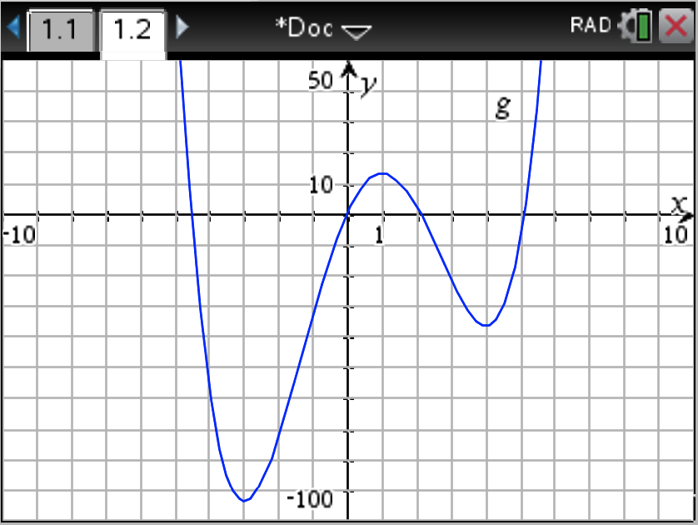

1. The figure represents the graph of a derivate function $f'(x)$. Sketch a possible

graph for the function $f(x)$ on the same grid. $\left[4\right]$

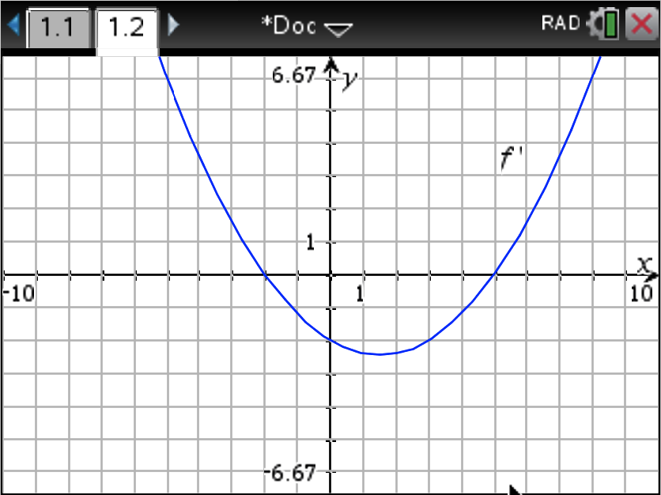

**- - - END OF EXAM - - -**