

**S6 MATHEMATICS – 3 PERIODS**

**PART A**

**DATE:**  10th, June 2019

**DURATION OF THE EXAMINATION:** 45 minutes

**Total: 35 points**

**Non Calculator**

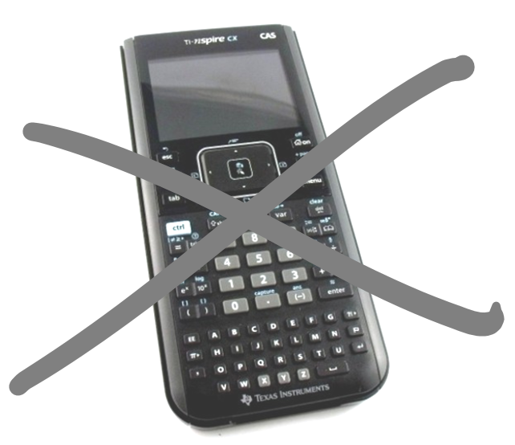

**NUMBER OF PUPILS: 10**

**EXERCISE 1-A: [5+6]**

A group of 30 students went on a camping trip.

1. Of these, 12 returned with both sunburns and insect bites and 20 reported sunburn. How many suffered only insect bites if it is known that three students suffered neither? Draw a **Venn-Diagram** to illustrate the situation.
2. In the group, 9 students had food allergies. Of the 16 girls in the group 5 had food allergies. A student from the group is picked at random. What is he probability that they don’t have food allergies given that they are a boy? Draw a **two-way table** to illustrate the situation.

**EXERCISE 2-A:** **[4+2]**

|  |  |
| --- | --- |
|  | A lock consists of three wheels with the digits 0 to 9.   1. Knowing that each digit has only been used once, what is the maximum number of attempts that must be made before the lock will open? 2. What is the probability that the lock will open on the first try? |

**EXERCISE 3-A:** **[4+4]**

Consider the data set described by the following frequency table :

|  |  |  |  |  |  |  |  |  |  |  |  |  |  |
| --- | --- | --- | --- | --- | --- | --- | --- | --- | --- | --- | --- | --- | --- |
| |  |  | | --- | --- | | Scores | Frequency | | 10 | 1 | | 20 | 3 | | 30 | 4 | | 50 | 6 | | 70 | 1 | | 1. Calculate its Mode, Median, Range and Inter-Quartile range. 2. Draw a Box-Plot that represents this data set. |

**EXERCICE 4-A:** **[5+5]**

1. A sequence has general formula $u_{n}=15+3(n-1)$
2. What type of sequence is it? (State $u_{1}$ and r or d).
3. Calculate its 21st term.
4. A geometric sequence has the first term equal to 10 and the common ratio equal to $-2$.
5. Write a recurrence formula to describe this sequence.
6. Calculate the terms $u_{2,}{ u}_{3}$ and $u_{4}$.