

**S6 MATHEMATICS – 3 Periods**

**PART B**

**DATE:**  10th, June 2019

**DURATION OF THE EXAMINATION:** 90 minutes

**Total: 65 points**

**With Calculator**



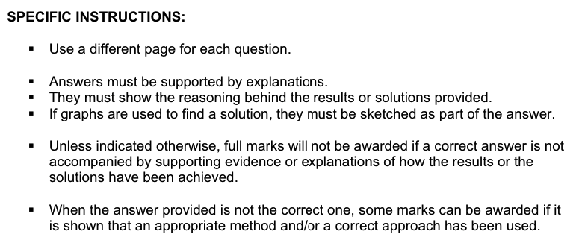

**NUMBER OF PUPILS: 10**

**EXERCISE 1-B:**

In New Portland there are only two car manufactures, Homba and Tayita. 58% of the cars are produced

by Homba and the rest is produced by Tayita. No cars by other manufacturers exist.

7% of the cars produced by Homba do not meet the rigorous emission standards set by New Portland’s environmental agency, whereas 87% of the cars produced by Tayita do meet these standards.

1. Draw a tree diagram illustrating this situation. All notation must be defined

and all branches of the tree must be clearly labelled. **[5]**

1. What is the probability that a car meets the emission standards given that it

was produced by Homba? **[2]**

1. What is the probability that a car was produced by Tayita **and** meets the emission

standards? **[2]**

1. If a car is selected at random, what is the probability that it meets the emission standards? **[3]**
2. Given that a car meets the emission standards, what is the probability it was

produced by Tayita? **[3]**

A study shows that the probability of a car meeting the emission standards is equal to 90%

Ten cars are randomly selected.

1. Write the formula that allows you to calculate the probability that **k** cars out

of the ten chosen meet the emission standards. **The use of the formula must be**

**carefully justified. [4]**

1. What is the probability that all cars chosen will meet the emission standards? **[2]**
2. What is the probability that 8 cars meet the emission standards? **[2]**
3. What is the probability that at least 8 cars meet the emission standards? **[2]**

**EXERCISE 2-B:**

|  |  |
| --- | --- |
| Professor Fry, a famous biologist, conducted a study on the population of viper snakes on an island of the coast of Brazil known as Snake Island.  When the study began, the population of this endangered species was 4000 individuals. The study indicated that the population was **decreasing** by 5% each year due to competition for resources. |  |

1. Write a formula for the population in year $n$ $(u_{n})$. Justify. **[3]**
2. **Copy and complete** the table **[1.5]**

|  |  |  |  |  |
| --- | --- | --- | --- | --- |
| Beginning of year | 1 | 2 | 3 | 4 |
| Population | 4000 |  |  |  |

1. What will the population be at the beginning of year 10? **[1.5]**
2. When was the initial population halved? **[2]**

After 15 years the trend was reversed and the population started increasing following the formula

$P\left(n\right)=500+\frac{4000}{2+({0.7)}^{n}}$ ( $n$ is the number of years from year 15 onwards)

1. Due to the limited amount of resources, the island can only sustain the life

of 2800 individuals. Is this population growth sustainable? **Justify your answer**. **[2]**

**EXERCISE 3-B:**

Australian biologist, Professor Fry, conducted a study on the length of the Golden Lancehead viper,

a venomous snake, living on Snake Island in Brazil.

He measured the length size of a sample of snakes and recorded his data into the following table.

(Length values in table were rounded to the nearest cm).

|  |  |  |  |  |  |  |  |  |  |  |  |  |  |  |  |
| --- | --- | --- | --- | --- | --- | --- | --- | --- | --- | --- | --- | --- | --- | --- | --- |
| Length (cm) | 75 | 76 | 77 | 78 | 79 | 80 | 81 | 82 | 83 | 84 | 85 | 86 | 87 | 88 | 89 |
| Frequency | 20 | 31 | 52 | 56 | 65 | 68 | 72 | 90 | 80 | 82 | 38 | 19 | 12 | 9 | 6 |

1. Calculate the mean, median, mode and range for this data set. **[2]**
2. Calculate Q1 and Q3 for this data set. **[2]**
3. Calculate the standard deviation for this data set. **[1]**
4. Give an interpretation of the standard deviation. **[2]**
5. What percentage of the snakes measured 80 cm? **[2]**
6. What percentage of the snakes measured less than 80 cm? **[2]**

**EXERCISE 4-B:**

Professor Fry invested a sum of money in a bank account at the start of the year. The bank

gives him the same interest rate every year. At the start of the 5th year, his investment will be

worth 236 150 € and at the start of the 10th year his investment will be worth 287 313 €.

1. Find the interest rate he gets. **[5]**
2. Find the original amount of money he put into the account. **[5]**

**EXERCISE 5-B:**

Professor Fry and 11 colleagues from his team went to a restaurant to commemorate the success of

the research conducted on Snake Island. At the end of the meal, they decided to randomly select three

members of the group to pay the bill.

1. In how many ways can these three people be selected? **[3]**
2. What is the probability that Professor Fry will **not** have to contribute to the payment? **[3]**
3. In the group there are 3 biologists, 5 zoologists and 4 veterinarians. What is the probability

that exactly one of each profession will be selected? **[3]**

**- - - END OF EXAM - - -**