

**S6MA3ENA – Semestre 1**

**MATHEMATICS 3**

**Part A**

**Date:** Wednesday 15th December 2021

**DURATION OF EXAMINATION:**

1 hour 30 minutes (90 minutes)

**Answer ALL questions**



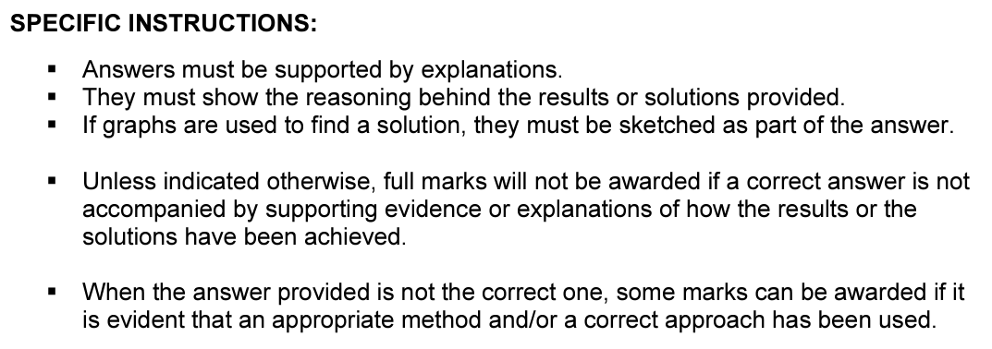

K. Osborne

|  |  |
| --- | --- |
| **PART A** | **Marks** |
| 1. Give the derivative $f'(x)$ of the following functions: 2. Consider the graph of the function $f$ shown below.   The line r is a tangent line to the graph of $f$ at point A.    (a) Use the information in the diagram to find the equation of the line r.  (b) Given that $f\left(x\right)=x^{3}-3x^{2}+2x+1$, use the diagram or otherwise to find the value of .   1. A town`s population is growing linearly. In 2018 the population was 5000. By 2020 the population had increased to 7400. 2. Give the function $P(t)$ where $P$ is the population and $t$ is the number of years since 2018. 3. Use your function $P(t)$ to predict the population in 2025.      1. According to this model in which year will the population reach 19400? 2. The function is defined as . 3. Determine the coordinates of the y-intercept. 4. Calculate 5. Determine the derivative. 6. For what value of $x$ does the function $f\left(x\right)$ have a turning point? State the nature of the turning point and explain your answer. 7. Find the equation of the tangent to the curve at the point (1,2). 8. The point A is a point on the graph of $f$. The gradient at the point A is equal to 12. Find the coordinates of the point A. 9. The diagram below shows the graph of the function $f\left(x\right)=\frac{ax+b}{x+c}$.   The dotted blue lines represent the asymptotes. The graph passes through the point .   1. Give the equation of the vertical asymptote. 2. State the domain of the function. 3. Find value of . 4. Give the equation of the horizontal asymptote. 5. State the range of the function. 6. Find value of . 7. A student says that the value of $b$ is 1. Are they correct? You must justify your answer.      1. The graph of the derivative $f^{'}\left(x\right)$ is given below.      1. Give the $x$-coordinates of the two turning points. 2. For which values of $x$ is the graph of $f\left(x\right)$ increasing? 3. For which value of $x$ does $f(x)$ reach a minimum? 4. Sketch a possible graph of $f\left(x\right)$, given that the point $\left(8,0\right)$ lies on the graph of. 5. The graph below is the graph of the function $f\left(x\right).$    Which of the 4 graphs below is the corresponding graph of $f^{'}\left(x\right)$?  For each graph you **must** explain why it is or is not the correct graph.  B  A      D  C | 2  2  2  4  4  3  2  2  2  2  2  3  4  4  2  2  2  2  2  2  2  2  2  2  3  4 |