

**S6MA3ENA – Semestre 1**

**MATHEMATICS 3**

**Part B**

**Date:** Wednesday 15th December 2021

**DURATION OF EXAMINATION:**

45 minutes

**Answer ALL questions**



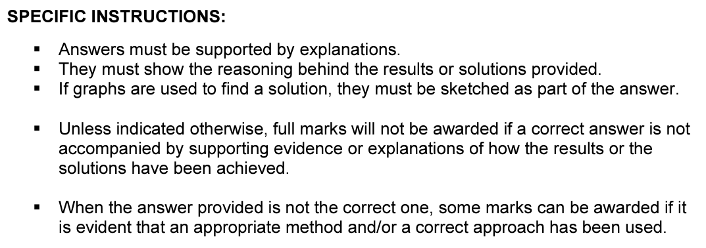

K. Osborne

|  |  |
| --- | --- |
| **PART A** | **Marks** |
| 1. Consider the function . 2. Determine the coordinates of the turning points of $f\left(x\right)$, giving your answer to 2 decimal places. 3. Draw a table of signs. 4. Use the table of signs to determine the nature of the turning points. | 4  2  2 |
| 1. Consider the function . 2. Explain why the function is undefined when . 3. State the domain of the function. 4. Give the coordinates of the $y$-intercept of . | 1  2  2 |
| 1. Karen plays volleyball and throws a ball vertically. The height $h(t)$ (in meters) as a function of the time $t$ (in second) of the ball is given by the formula: . 2. From what height does Karen throw the ball? 3. Show that the ball reaches its highest point at s. 4. Calculate the ball`s maximum height. 5. For how long is the ball in the air? | 2  3  3  3 |
| 1. A group of scientists decides to investigate a population of insects in a large field. It is found that the starting population 100 and that the population increases exponentially by 20% every week.   Two students each write down a formula to model the population $P$ at a time $t$, where $t$ is the number of days since the start of the investigation:  Formula A: $P\left(t\right)=100t+1.2$ Formula B:   1. Explain why formula B is the correct formula and why formula A is incorrect. 2. Calculate the number of insects after 2 weeks, to the nearest whole number. 3. Copy and complete the table of values below, giving your answers to the nearest whole number:  |  |  |  |  |  | | --- | --- | --- | --- | --- | | **Number of days** | **5** | **10** | **15** | **20** | | **Population** |  |  |  |  |  1. After how many days will the population exceed 4600?   Another group of scientists investigates a population of insects in a different large field. They record their results in the table below:   |  |  |  |  |  |  | | --- | --- | --- | --- | --- | --- | | **Number of days** | **0** | **5** | **10** | **15** | **20** | | **Population** | **100** | **340** | **580** | **820** | **1060** |  1. Explain why the results follow a **linear** model. 2. Use the information in the table of values to write down a formula to model the population $P$ at a time $t$, where $t$ is the number of days since the start of the investigation. | 2  2  2  2  1  2 |