Mathematics Syllabus 3 Periods
Example assessment Baccalaureate

On the following pages, there is first a full example of a BAC examination, accompanied with the answers.

Part A – no device allowed
Question A1
Given are the graph of a function $f$ and its tangent line $T$ in the point with  $x=2$.  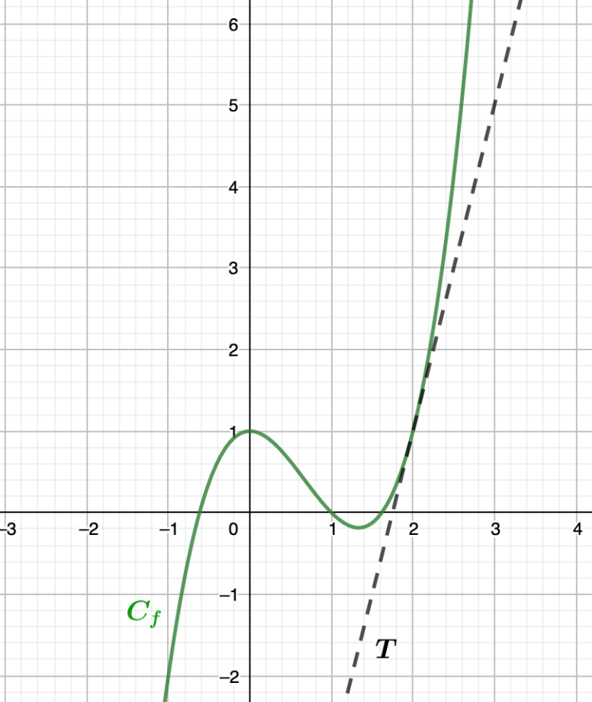  Determine $f\left(2\right)$ and $f'\left(2\right)$ | 5
Question A2
A clothing store delivers orders made online. Of the 400 orders that have been sent, 60 have a colour problem, 90 have a size problem and 260 have no problem at all. If one piece of clothing is taken randomly, calculate the probability that it has a colour issue, knowing that it also has a size problem. | 5

Question A3
Given are the graphs of the derivatives of the functions $f$ and $g$.  - Determine whether the function $f$ has an extremum within the shown domain and justify your answer. If $f$ has an extremum, determine its nature.  - Determine whether the function $g$ has an extremum within the shown domain and justify your answer. If $g$ has an extremum, determine its nature. | 2.5  2.5

Question A4
For a road trip, the car needs to be in an impeccable state, so it must be checked. The garage advises to change the tyres. They have two types, and you are looking at the distance that both types can cover. The distance that tyre A can cover is normal distributed with a mean of 60 000 km and a standard deviation of 8 000 km, while the distance of tyre B is normal distributed with a mean of 64 000 km and a standard deviation of 4 000 km.  Investigate which tyre you should choose if you would like to have the highest probability of driving at least 52000 km with your tyres. | 5
Question A5
Alper uses a GPS average speed measuring device when driving. Alper drives on a motorway restricted to 120km/h. The device measured his average speed to be 110 km/h.  One week later he receives a speeding fine from the above journey where he was caught by a properly calibrated speed radar to be going more than 130km/h.  Discuss why Alper thought he was following the law and why the speed radar caught him speeding.  Use examples and full reasoning, for example by drawing a graph and using the vocabulary studied in class. | 5

Question A6
We consider the following scatter diagrams with the corresponding linear correlation coefficients $r_{1},r_{2},r_{3}$ and $r_{4}$.  Arrange these correlation coefficients in ascending order and explain your answer.  Scatter plot 1, with coefficient $r_{1}$ Scatter plot 2, with coefficient $r_{2}$  Scatter plot 3, with coefficient $r_{3}$ Scatter plot 4, with coefficient $r_{4}$ | 5

Question A7
In a region of Europe, owls hunt voles (field mice). The number of owls and voles has been studied since 2010. We begin to study the evolution of the number of each of its species in 2010. The number of voles is given by the function below:  $$f\left(t\right)=1500sin\left(bt\right)+2000$$  with $t$ the number of years since 2010 and $b$ a real number.  The number of owls is given by the following function:  $$g\left(t\right)=800sin\left(\frac{4π}{5}\left(t−0.9\right)\right)+1500$$  with $t$ still the number of years since 2010.  The graphs of the functions $f$ and $g$ are given below  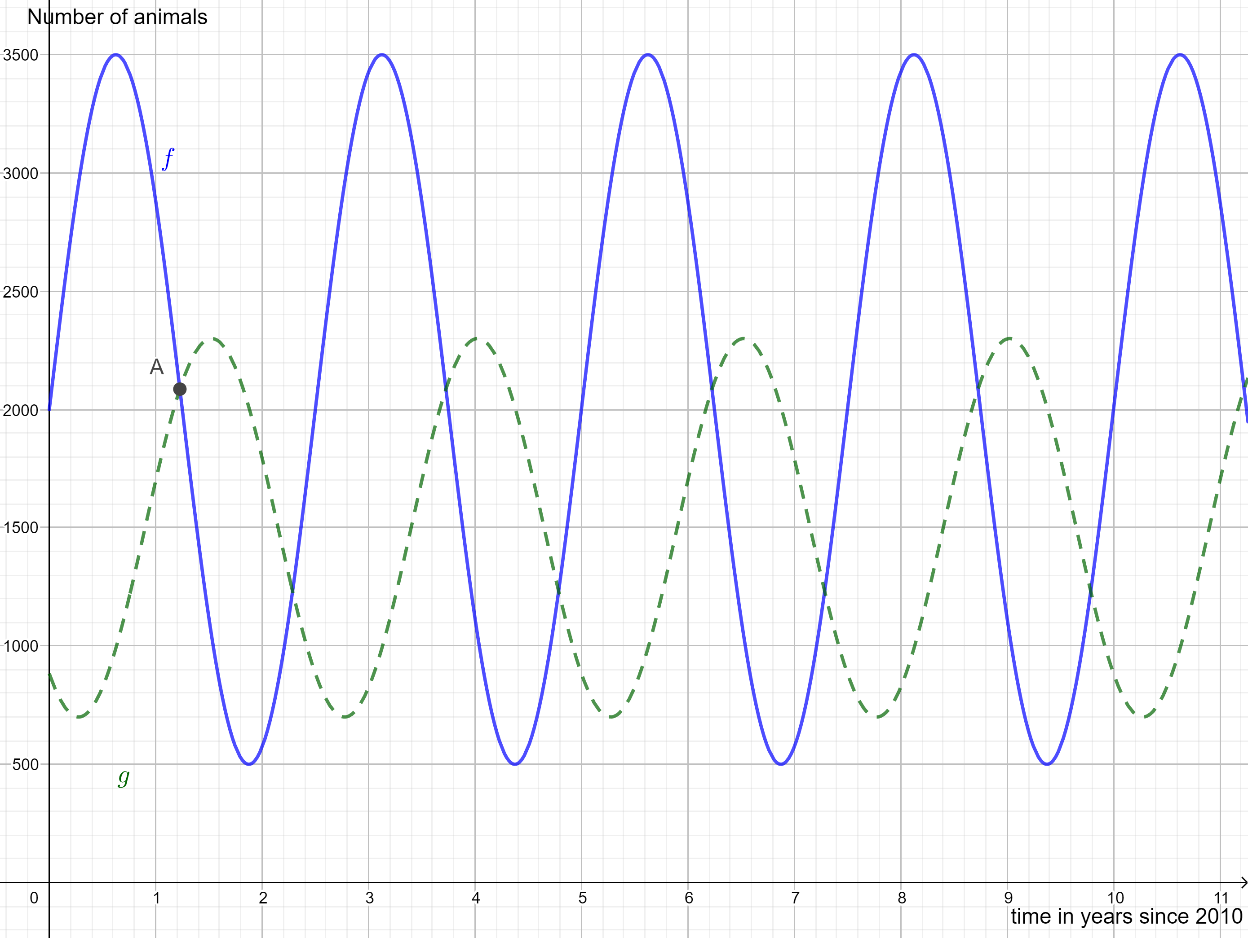  with the dotted curve showing the number of owls and the continuous line showing the number of voles.  - Determine the period of $f$ and hence determine the value of the parameter $b$.  - Determine the coordinates of point $A$ (to one decimal place for $t$) and interpret the outcome in this context.  - Determine in which year (after 2020) the number of owls will peak again and justify your answer.  - State what happens when the number of prey decreases. | 1  1.5  1  1.5

Question A8
In a school, teachers claim that more than 20% of the pupils arrive late for class.  - State the null hypothesis $H_{0}$ and the alternative hypothesis $H_{1}$ from the teachers’ point of view. Explain your answer.  The pupils claim that the teachers exaggerate and that only a maximum of 10% of the pupils arrive late for class.  - State the null hypothesis $H_{0}$ and the alternative hypothesis $H_{1}$ in case the students would set up the investigation. Explain your answer. | 3  2
Question A9
Consider a random variable X. The table below show the probability distribution of X:  $$x_{i}$$ $$0$$ $$1$$ $$2$$ $$3$$ $$4$$  $$p_{i}$$ $$2a$$ $$a$$ $$0.1$$ $$0.3$$ $$a$$  Calculate the expected value of $X$. | 5

Question A10
On a trip, you have bought some bread but forgot about it. Four days later you have found it again at the bottom of your bag, but mould is developing on some parts. The mould develops according to the following formula:  $$P\left(t\right)=0.5⋅e^{ln\left(1.5\right)t}$$  with $P$ the percentage of bread covered and $t$ the time in days, with $t=0$ four days after buying the bread.  - This formula can also be written in another form.  Choose the right form ($Q_{1},Q_{2},Q_{3}$ or $Q_{4}$) and justify your answer.  $Q_{1}\left(t\right)=0.5⋅{ln\left(1.5\right)}^{t}$ $Q_{2}\left(t\right)=1.5⋅{0.5}^{t}$  $Q_{3}\left(t\right)=0.5⋅{1.5}^{t}$ $Q_{4}\left(t\right)=1.5⋅{ln\left(0.5\right)}^{t}$  - Calculate what percentage of the bread is covered in mould, 5 days after buying the bread | 3  2

