Mathematics Syllabus 3 Periods
Example assessment Baccalaureate

On the following pages, there is first a full example of a BAC examination, accompanied with the answers.

Solutions to part A
Question A1
Given are the graph of a function $f$ and its tangent line $T$ in the point with $x=2$.  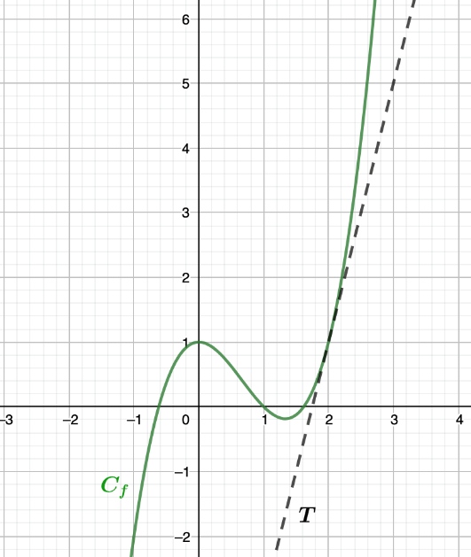  Determine $f\left(2\right)$ and $f'\left(2\right)$  Solutions:  Reading from graph: $f\left(2\right)=1$ (2 points)  The gradient of the tangent line to the graph is equal to the derivative of the graph in that point.  Gradient of T equals 3 (reading from graph), therefore $f^{'}\left(2\right)=4$ (3 points) | 5

Question A2
A clothing store delivers orders made online. Of the 400 orders that have been sent, 60 have a colour problem, 90 have a size problem and 260 have no problem at all. If one piece of clothing is taken randomly, calculate the probability that it has a colour issue, knowing that it also has a size problem.  Solution:  Event C: the order has a colour defect.  Event S: the order has a sizing defect.  Contingency table/Venn diagram/other calculations:  U (400)  S(90)  C (60)  260  =10  $$90−x+x+60−x+260=400⇔410−x=400⇔x=10$$  $$P\left(C | S\right)=\frac{P\left(C∩S\right)}{P\left(S\right)}=\frac{\frac{10}{400}}{\frac{90}{400}}=\frac{10}{90}=\frac{1}{9}$$ | 5

Question A3
Given are the graphs of the derivatives of the functions $f$ and $g$.  - Determine whether the function $f$ has an extremum within the shown domain and justify your answer. If $f$ has an extremum, determine its nature.  - Determine whether the function $g$ has an extremum within the shown domain and justify your answer. If $g$ has an extremum, determine its nature.  Solution:  $$x$$ 3.2  $$f'\left(x\right)$$ - 0 +  $$f\left(x\right)$$ æ ä  - There is a zero for $x≈3.2$, and f’ is negative for x<3.2 and f’ is positive x>3.2 See table.  The table shows that f has an extremum for $x=3.2$ and it is a minimum.  - There is a zero for x=0. See table.  The table shows that there is no minimum or maximum, so $g$ has no extremum for $x=0$ or any other point in the shown domain.  $$x$$ 0  $$g'\left(x\right)$$ + 0 +  $$g\left(x\right)$$ ä ä | 2.5  2.5

Question A4
For a road trip, the car needs to be in an impeccable state, so it must be checked. The garage advises to change the tyres. They have two types, and you are looking at the distance that both types can cover. The distance that tyre A can cover is normal distributed with a mean of 60 000 km and a standard deviation of 8 000 km, while the distance of tyre B is normal distributed with a mean of 64 000 km and a standard deviation of 4 000 km.  Investigate which tyre you should choose if you would like to have the highest probability of driving at least 52000 km with your tyres.  Solution  The red curve belongs to A and the blue curve belongs to B.  52000 km is one standard deviation lower than the mean 60 000 km for tire A, that means that the probability of driving more than 52 000 km with tire A is 50%+34%=84%.  52000 is 3 standard deviations (3 times 4000) away from the mean 64000 km for tire B. the probability of driving more than 52000 km with tire B is 50%+34%+13.5%+2.35%=99.85%.  Tire B has the highest probability, so in this case you should choose B. | 5

Question A5
Alper uses a GPS average speed measuring device when driving. Alper drives on a motorway restricted to 120km/h. The device measured his average speed to be 110 km/h.  One week later he receives a speeding fine from the above journey where he was caught by a properly calibrated speed radar to be going more than 130km/h.  Discuss why Alper thought he was following the law and why the speed radar caught him speeding.  Use examples and full reasoning, for example by drawing a graph and using the vocabulary studied in class.  Solution:  Solution (Way more than needed)  There is a difference between instantaneous speed, which the Speed Radar uses, and average speed that his GPS device calculates.  All that average speed is calculating is the total distance driven over a particular time. Therefore in one hour he travelled 110 km. What average speed does not tell you is a speed at a particular instant.  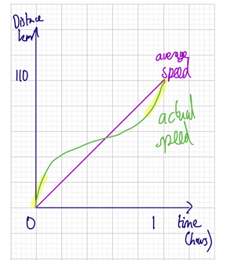  Compare the following:  Although the actual speed function and the average speed function are both covering a distance of 110km in 1 hour the actual speed is not assumed to be constant which is exactly what the average speed suggests.  The highlighted parts of the actual function graph show the points when the speed was greater than the average speed and thus potentially when Alper was caught speeding.  The gradient of the average speed is constant at 110 km/h. However the actual speed appears to be modelled on a cubic function which means that the gradient (speed) is constantly changing.  To determine the average speed we just need to points and form a straight line to determine the instantaneous speed we must draw a tangent and calculate its gradient or we can differentiate the speed function and use the time at that particular instant to calculate the speed. If the two points to create the average speed have too large a difference in their times then more error is introduced. To have an instantaneous speed the difference between the two times must be minimised.  I propose that Alper sets his GPS device to measure average speed for every minute rather than the whole journey to avoid being caught! | 5

Question A6
We consider the following scatter diagrams with the corresponding linear correlation coefficients $r_{1},r_{2},r_{3}$ and $r_{4}$.  Arrange these correlation coefficients in ascending order and explain your answer.  Scatter plot 1, with coefficient $r_{1}$ Scatter plot 2, with coefficient $r_{2}$  Scatter plot 3, with coefficient $r_{3}$ Scatter plot 4, with coefficient $r_{4}$  Solution  the linear correlation coefficient is between -1 and 1, with it being -1 if all points are on one line and the line is decreasing and it being 1 if all points are on one line and the line is increasing.  If there is no pattern of a line whatsoever the linear correlation coefficient is 0.  Scatter plots 1 and 3 are both decreasing/negative, but in plot 1 the points are closer to forming one line, therefore it will be closer to -1 than for plot 3, and therefore $r_{1}$ will be the smallest, followed by $r_{3}.$  Plot 2 is everywhere and therefore $r_{3}$ will be close to zero. The points on plot 4 are almost all on an increasing line, therefore $r_{4}$ will be close to 1.  Order: $r_{1},r_{3},r_{2},r_{4}$ | 5

Question A7
In a region of Europe, owls hunt voles (field mice). The number of owls and voles has been studied since 2010. We begin to study the evolution of the number of each of its species in 2010. The number of voles is given by the function below:  $$f\left(t\right)=1500sin\left(bt\right)+2000$$  with $t$ the number of years since 2010 and $b$ a real number.  The number of owls is given by the following function:  $$g\left(t\right)=800sin\left(\frac{4π}{5}\left(t−0.9\right)\right)+1500$$  with $t$ still the number of years since 2010.  The graphs of the functions $f$ and $g$ are  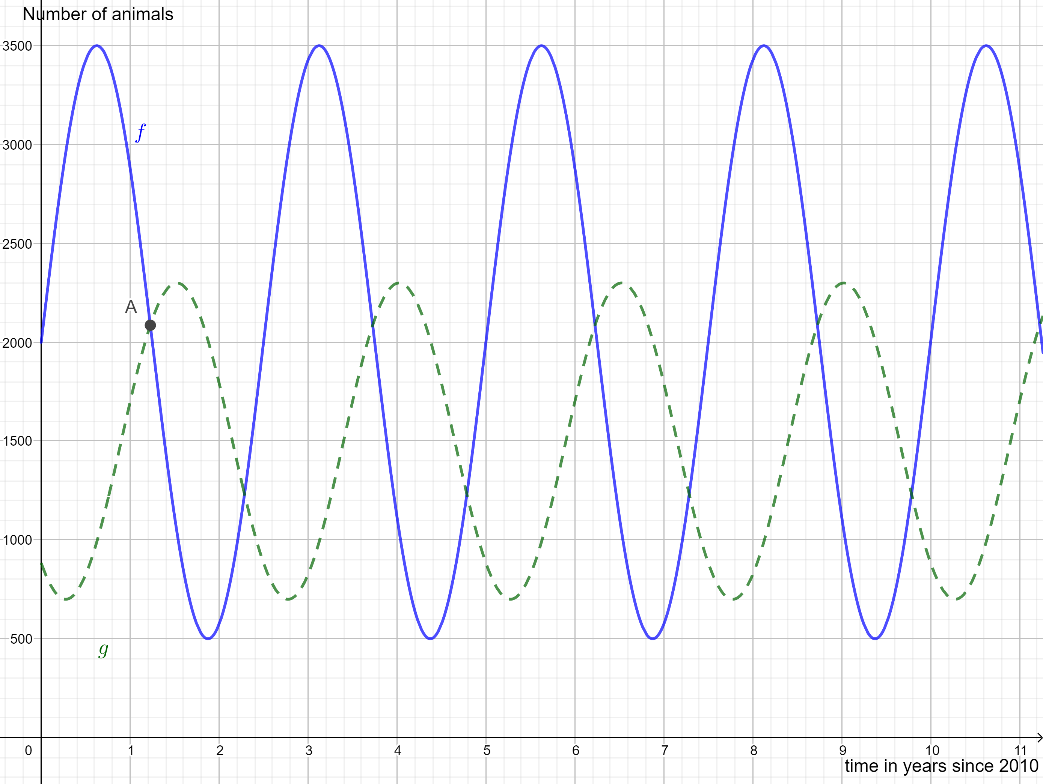  with the dotted curve showing the number of owls and the continuous line showing the number of voles.  - Determine the period of $f$ and hence determine the value of the  parameter $b$.  - Determine the coordinates of point $A$ (to one decimal place for $t$) and interpret the outcome in this context.  - Determine in which year (after 2020) the number of owls will peak again and justify your answer.  - State what happens when the number of prey decreases  Solution:  - 2 periods take 5 years, so the period of f is 2.5 years. $b=\frac{2π}{p}=\frac{2π}{2.5}=\frac{4π}{5}$.  - Reading from graph gives $A\left(1.2;2100\right)$. So,1.2 years after 2010 there are the same amount of owls and voles.  - In 2020, t=10, there is a maximum for $t=10+\frac{2.5}{4}=10.625$. The next maximum would be 2.5 years later, so approximately 13.1 years after 2010 so in 2023.  - If the number of prey decreases, the number of owls will decrease shortly after too, but there is a delay. | 1  1.5  1.5  1
Question A8
In a school teachers claim that more than 20% of the pupils arrive late for class.  - State the null hypothesis $H_{0}$ and the alternative hypothesis $H_{1}$ from the teachers’ point of view. Explain your answer.  The pupils claim that the teachers exaggerate and that only a maximum of 10% of the pupils arrive late for class.  - State the null hypothesis $H_{0}$ and the alternative hypothesis $H_{1}$ in case the students would set up the investigation. Explain your answer.  Solution  Let $p$ be the proportion of students who arrive late.  - $H_{0}:p=0.2$  $H_{1}:p>0.2$  - $H_{0}:p=0.1$  $H_{1}:p<0.1$ | 3  2

Question A9
Consider a random variable X. The table below show the probability distribution of X:  $$x_{i}$$ $$0$$ $$1$$ $$2$$ $$3$$ $$4$$  $$p_{i}$$ $$2a$$ $$a$$ $$0.1$$ $$0.3$$ $$a$$  Calculate the expected value of $X$.  Solution  It is a probability distribution so all probabilities should add up to 1:  $2a+a+0.1+0.3+a=1$$4a+0.4=1$$4a=0.6$$a=0.15$  $E\left(X\right)=x_{1}⋅p_{1}+x_{2}⋅p_{2}+…+x_{5}⋅p_{5}$$0⋅2a+1⋅a+2⋅0.1+3⋅0.3+4⋅a$$5a+0.2+0.9$$5⋅0.15+1.1$$1.85$ | 5

Question A10
On a trip, you have bought some bread but forgot about it. Four days later you have found it again at the bottom of your bag, but mould is developing on some parts. The mould develops according to the following formula:  $$P\left(t\right)=0.5⋅e^{ln\left(1.5\right)t}$$  with $P$ the percentage of bread covered and $t$ the time in days, with $t=0$ four days after buying the bread.  - This formula can also be written in another form.  Choose the right form ($Q_{1},Q_{2},Q_{3}$ or $Q_{4}$) and justify your answer.  $Q_{1}\left(t\right)=0.5⋅{ln\left(1.5\right)}^{t}$ $Q_{2}\left(t\right)=1.5⋅{0.5}^{t}$  $Q_{3}\left(t\right)=0.5⋅{1.5}^{t}$ $Q_{4}\left(t\right)=1.5⋅{ln\left(0.5\right)}^{t}$  - Calculate what percentage of the bread is covered in mould, 5 days after buying the bread  Solution:  - $P\left(t\right)=0.5⋅e^{ln\left(1.5\right)t}=0.5⋅{\left(e^{ln\left(1.5\right)}\right)}^{t}=0.5⋅{1.5}^{t}=Q_{3}\left(t\right)$  therefore $Q_{3}$ is an alternative form for $P$.  - 5 days after buying à $t=1$, so $P\left(1\right)=0.5⋅1.5=0.75$  0.75% of the bread is covered, 5 days after buying it. | 3  2

