Mathematics Syllabus 3 Periods
Example assessment Baccalaureate

On the following pages, there is first a full example of a BAC examination, accompanied with the answers.

Part B – device allowed, no CAS
Question B1 page 1/3  Elections: Representing a Population | 25
The S7 year group at a European School, containing 150 pupils, is to be represented on the Pupil’s Committee for their school. There are to be 5 pupils from this year group chosen to represent the year. Of the 150 pupils 60 are male.  - Calculate the probability at choosing one male pupil at random from this year group.  To better represent the pupil population a questionnaire is given to each member of the S7 year group. It is noted that of the 150 pupils 30 take their lunch at the canteen and the rest have lunch at the local shopping mall. 8 male pupils take their lunch at the canteen  - Determine the probability that given a non-male pupil is chosen they have their lunch at the mall.  At the same school all year groups are proportionally represented based on their year group size. In the Pupils’ Committee there are the following members:  Year group S1 S2 S3 S4 S5 S6 S7  Number 4 6 4 5 4 6 5  - From the Pupils’ Committee they need to select a group of 5 pupils to represent them at a European Schools conference.  Determine how many different ways there are of selecting 3 pupils from S7 and 2 pupils from S6 from the Pupils’ Committee. | 1  3  3

Question B1 (continued) page 2/3
- The lower school (S1 to S3) are planning an activity. 3 members of the Pupils’ Committee from S1, S2 and S3 form a group to plan this activity.  Calculate the probability that if the members are selected at random the 3 members come from different year groups.  A large country is having its General Election. It is known that 30% of the population will vote for the Turquoise Party.  - Justify why the expected value may differ from the actual value.  A group of 20 people from the population are chosen at random.  - From this group 5 are asked who they will vote for.  Determine the probability that at least 2 of them will not vote for the Turquoise Party. | 5  2  6

Question B1 (continued) page 3/3
In one particular country the voter turnout has been seen to be following an exponential model. The data for the voter turnout is:  Year 1989 1994 1999 2004 2009  Turnout % 74 67 60 54 49  In the following question you will be asked to determine a suitable model and apply this model.  - Justify fully which of the following would be the most suitable model to apply to this data and then determine the year when the rate at which the turnout decreases is less than -0.9% between elections years.  A: $f\left(x\right)=74.056⋅{\left(0.979411\right)}^{x}$  B: $f\left(x\right)=0.979411x+74.056$  C: $f\left(x\right)={\left(0.979411\right)}^{x}$  You may find the following useful in your answer. The following shows the derivative function of the exponential model.  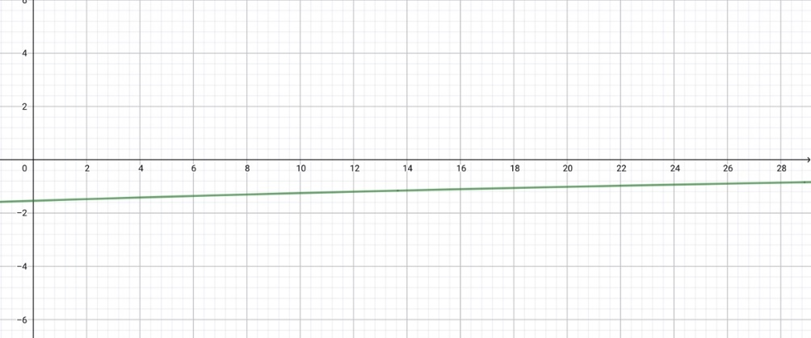 | 5

Question B2 page 1/3  Dinner problems | 25
Part I, II and III can be answered independent of one another  Part I  21 friends decide to meet up for dinner. Because of traffic, the probability of a friend arriving on time is 1/3. It is assumed that each friend arrives on their own.  - Calculate the probability of exactly 12 friends out of 21 arriving on time for dinner.  - These friends reunite again many times in the same conditions. Determine the average number of friends present on time at these events. | 4  3

Question B2 page 2/3
Part II  The analysis of the road speed databases shows the big variability in the time distribution of the movement of cars within a big agglomeration. The following graphs show this variability of distribution of time for the motorway. Each of these graphs correspond to the time it takes to travel 20 km at two different hours of the day.  - State the type of the above distributions.  - Determine which situation corresponds to the peak hours and explain your answer.  - Models are used to predict future events and the situations above could be used as such.  Determine which situation (Situation 1 or Situation 2) will give the most reliable prediction for your travel time and justify your answer.  - In Situation 1, the probability that the time of the travel takes more than 25 minutes is 0.048 (rounded to 3 decimal places).  Find the probability that the travel time is between 15 and 25 minutes. | 1  2  3  3

Question B2 page 3/3
Part III  At the dinner, a discussion takes place about electric cars and how they are developed. The diagram below shows the evolution of the number of electric cars in the world from 2010 to 2020.  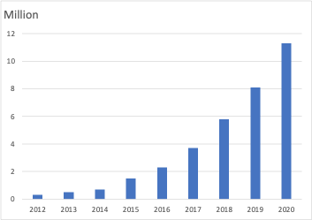  Source: www.iea.org  - One of the friends, using an application, represents the situation by the function:  $f\left(x\right)=0,275x^{2}−2,165x+5,415$with $x$ the number of years since 2010 and $f\left(x\right)$ the number of electric cars in millions.  Determine whether the model is suitable for the years 2017 to 2020. Justify your answer.  - Calculate $f^{'}\left(9\right)$ and interpret the result.  - The title of an article from the same source says:  "Between 145 and 230 million electric vehicles in the world in 2030".  Argue whether the formula from question g matches the title. | 3  3  3

