Mathematics Syllabus 3 Periods
Example assessment Baccalaureate

On the following pages, there is first a full example of a BAC examination, accompanied with the answers.

Solutions to part B
Question B1  Elections: Representing a Population | 25
The S7 year group at a European School, containing 150 pupils, is to be represented on the Pupil’s Committee for their school. There are to be 5 pupils from this year group chosen to represent the year. Of the 150 pupils 60 are male.  - Calculate the probability at choosing one male pupil at random from this year group.  To better represent the pupil population a questionnaire is given to each member of the S7 year group. It is noted that of the 150 pupils 30 take their lunch at the canteen and the rest have lunch at the local shopping mall. 8 male pupils take their lunch at the canteen  - Determine the probability that given a non-male pupil is chosen they have their lunch at the mall.  Solution:  - P(choose one male)$\frac{60}{150}=\frac{2}{5}$ (1 method)  - With a contingency/two-way table for example:  Male Non-male Total  School 8 22 30  Mall 52 68 120  Total 60 90 150  So P(lunch at mall|non-male)$\frac{68}{90}=\frac{34}{45}$  (2p K&C, 1M) | 1  3

Question B1 (continued)
At the same school all year groups are proportionally represented based on their year group size. In the Pupils’ Committee there are the following members:  Year group S1 S2 S3 S4 S5 S6 S7  Number 4 6 4 5 4 6 5  - From the Pupils’ Committee they need to select a group of 5 pupils to represent them at a European Schools conference.  Determine how many different ways there are of selecting 3 pupils from S7 and 2 pupils from S6 from the Pupils’ Committee.  - The lower school (S1 to S3) are planning an activity. 3 members of the Pupils’ Committee from S1, S2 and S3 form a group to plan this activity.  Calculate the probability that if the members are selected at random the 3 members come from different year groups.  Solution:  - 2 out of 6 S6 students, 3 out of 5 S7s (1p I/K&C highlighting info)  $\left(\begin{aligned}6 \\ 2\end{aligned}\right)⋅\left(\begin{aligned}5 \\ 3\end{aligned}\right)=\frac{6!}{2!4!}⋅\frac{5!}{3!2!}=15⋅10=150$ (1 method/digital)  Thus, there are 150 ways of selecting 3 S7 students and 2 S6s for the committee (1p communication)  - S1 – 4 pupils, S2 – 6 pupils and S3 – 4 pupils. As lower school can only have pupils from S1, S2 and S3 (1p I/K&C, highlighting info)  We must have 1 pupil from 4 in S1, 1 pupil from 6 in S2 and 1 pupil from 4 in S3. (1p communication, attempt to explain problem either mathematical or in words, but without mathematical notation the maximum marks cannot be awarded)  $\left(\begin{aligned}4 \\ 1\end{aligned}\right)⋅\left(\begin{aligned}6 \\ 1\end{aligned}\right)⋅\left(\begin{aligned}4 \\ 1\end{aligned}\right)=4⋅6⋅4=96$ (either Pascal’s triangle, knowledge, tool). So there are 96 ways to select the students with one per year group (1p M/C)  In total there are $\left(\begin{aligned}14 \\ 3\end{aligned}\right)=\frac{14!}{3!11!}=364$ ways to select 3 students from the lower years. (1p M)  Thus P(3 members are from different year groups)$\frac{96}{364}=\frac{24}{91}$ (1 C/M)  Or students could use a different approach by just counting which is just as valid, though not as easy.  S1 S2 S3 Number of ways  0 0 3 4C3=4  0 3 0 6C3=20  3 0 0 4C3=4  0 1 2 1x6x6=36  0 2 1 1x15x4=60  1 0 2 4x1x6=24  2 0 1 6x1x4=24  2 1 0 6x6x1=36  1 2 0 4x15x1=60  1 1 1 4x6x4=96  Total 364  (Pascal’s triangle/ systematic counting; 4p problem solving)  Thus P(3 members are from different year groups)$\frac{96}{364}=\frac{24}{91}$ (1 C/M) | 3  5

Question B1 (continued)
A large country is having its General Election. It is known that 30% of the population will vote for the Turquoise Party.  - Justify why the expected value may differ from the actual value.  A group of 20 people from the population are chosen at random.  - From this group 5 are asked who they will vote for. Determine the probability that at least 2 of them will not vote for the Turquoise Party.  Solution:  - If we assume that this is a binomial model or in fact a model of any kind it is based on past experience. The expected value using a binomial model is simply np.  When it comes time to vote people may have a last minute change of heart for a number of reasons and thus the expected will be different. (2p K&C/I)  This is a question to help those that have a comprehension but struggle with the mathematics. The marker must use judgement to see if full marks are justified. Some comment should make note of what expectation is.  - Realise this cannot be modelled by a binomial e.g.: This cannot be a binomial because 20 is too small of a number to be used (1p K&C)  Recognise that we are after the compliment event: P=100%-30%=70% (1p K&C)  Out of the 20 people chosen at random 14 will not vote for the Turquoise Party. 0.7x20=14. Some understanding that 14->13->12 etc. (1p Comp)  $X−numberofpeoplenotvotingforTurquoise$  $P\left(X≥2\right)=1−P\left(X<2\right)$ $P\left(X<2\right)=P\left(X=0\right)+P\left(X=1\right)$  $P\left(X=0\right)=\left(\begin{aligned}5 \\ 0\end{aligned}\right)∙\frac{6}{20}∙\frac{5}{19}∙\frac{4}{18}∙\frac{3}{17}∙\frac{2}{16}=0.0003869…$  $P\left(X=1\right)=\left(\begin{aligned}5 \\ 1\end{aligned}\right)∙\frac{6}{20}∙\frac{5}{19}∙\frac{3}{18}∙\frac{3}{17}∙\frac{14}{16}=0.01354…$  $P\left(X<2\right)=0.013926…$ (3p Digital) $P\left(X≥2\right)=0.986\left(3sf\right)$ (1pC)  OR $P\left(X≥2\right)=1−\left(\frac{\left(\begin{aligned}14 \\ 0\end{aligned}\right)∙\left(\begin{aligned}6 \\ 5\end{aligned}\right)}{\left(\begin{aligned}20 \\ 5\end{aligned}\right)}+\frac{\left(\begin{aligned}14 \\ 1\end{aligned}\right)∙\left(\begin{aligned}6 \\ 4\end{aligned}\right)}{\left(\begin{aligned}20 \\ 5\end{aligned}\right)}\right)=0.986\left(3sf\right)$ (4p Digi &com) | 2  6

Question B1 (continued)
In one particular country the voter turnout has been seen to be following an exponential model. The data for the voter turnout is:  Year 1989 1994 1999 2004 2009  Turnout % 74 67 60 54 49  In the following question you will be asked to determine a suitable model and apply this model.  - Justify fully which of the following would be the most suitable model to apply for this data and determine the year when the rate at which the turnout decreases is less than -0.9% between elections years.  A: $f\left(x\right)=74.056⋅{\left(0.979411\right)}^{x}$  B: $f\left(x\right)=0.979411x+74.056$  C: $f\left(x\right)={\left(0.979411\right)}^{x}$  You may find the following useful in your answer. The following shows the derivative function of the exponential model.  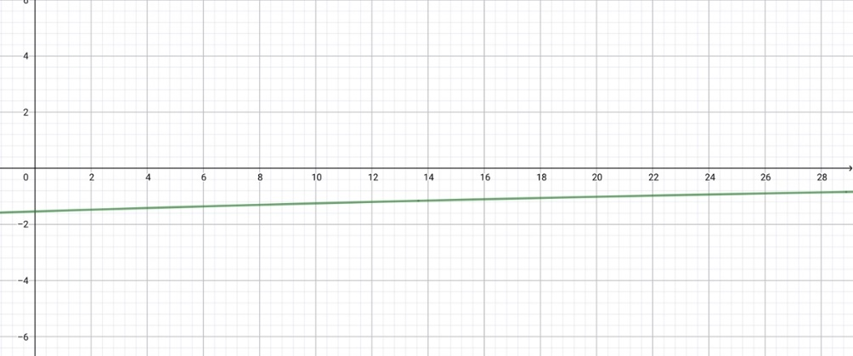  Solution  The data must be an exponential model so therefore the exponential model is:  A: $f\left(x\right)=74.056∙{\left(0.979411\right)}^{x}$Perhaps they also noted that it can be C. However, the starting value is 74. A comment justifying this.  This is using the years; 0, 5, 10, 15 and 20. This can be justified by inputting data into the function.  To find the rate we must differentiate the function:  $f^{'}\left(x\right)=−1.54066∙{\left(0.979411\right)}^{x}$Now find when $f^{'}\left(x\right)=−0.9$  This is at $x=25.84$ years and thus during 2014.  Or if using the supplied graph we read off -0.9 from the y axis and see that it is at about the 25th year. The pupil must then realise that this corresponds to the year 2014.  Or if using 1989, 1994, 1999, 2004, 2009  $f\left(x\right)=6.923E10∙{\left(0.979411\right)}^{x}$$f^{'}\left(x\right)=−1.440E18∙{\left(0.979411\right)}^{x}$Now find when $f^{'}\left(x\right)=−0.9$This is at $x=2014.84$ | 5

Question B2  Dinner problems | 25
Part I, II and III can be answered independent of one another  Part I  21 friends decide to meet up for dinner. Because of traffic, the probability of a friend arriving on time is 1/3. It is assumed that each friend arrives on their own.  - Calculate the probability of exactly 12 friends out of 21 arriving on time for dinner.  - These teachers reunite again many times in the same conditions. Determine the average number of friends present on time at these events.  Solution:  - For each friend there are only two possible outcomes:  - they arrive late with a probability of 1/3, an outcome called success  - they do not arrive late with a probability of 2/3, an outcome called failure. This is a Bernoulli test that is repeated 21 times in an identical and independent manner, the random variable $X$ equal to the number of late friends follows a binomial distribution with parameters $n=21$ and $p=\frac{1}{3}$.  $P\left(X=12\right)=0.014$The probability that 12 friends arrive late is 0.014.  - The expectation of the random variable $X$ is $E\left(X\right)=n⋅p=21⋅\frac{1}{3}=7$.  The average number of friends arriving on time for these appointments is 7. | 4  3

Question B2
Part II  (text deleted for space)  - State the type of the above distributions.  - Determine which situation corresponds to the peak hours and explain your answer.  - Models are used to predict future events and the situations above could be used as such. Determine which situation (Situation 1 or Situation 2) will give the most reliable prediction for your travel time and justify your answer.  - In Situation 1, the probability that the time of the travel takes more than 25 minutes is 0.048 (rounded to 3 decimal places).  Find the probability that the travel time is between 15 and 25 minutes.  Solution:  - It is a normal distribution.  - Note that the expected travel time is longer for situation 2 (45 minutes) than for situation 1 (20 minutes), so situation 2 (green curve) corresponds to peak hours.  - Situation 1 has a lower standard deviation because it is closer around its axis of symmetry and thus the probabilities for e.g. five minute intervals will be higher. This is therefore the most reliable model.  - As the bell curve is symmetrical with respect to the mean/expectation $μ=20$, then the probability that the travel time is between 15 and 25 minutes is equal to $1–2⋅0.048=0.904$. | 1  2  3  3

Question B2
Part III  At the dinner, a discussion takes place about electric cars and how they are developed. The diagram below shows the evolution of the number of electric cars from 2010 to 2020.  (graph taken out)  - One of the friends, using an application, represents the situation by the function: $f\left(x\right)=0,275x^{2}−2,165x+5,415$with $x$ the number of years since 2010 and $f\left(x\right)$ the number of electric cars in millions.  Determine whether the model is suitable for the years 2017 to 2020. Justify your answer.  - Calculate $f^{'}\left(9\right)$ and interpret the result.  - The title of an article from the same source says:  "Between 145 and 230 million electric vehicles in the world in 2030".  Argue whether the formula from question g matches the title.  Solution:  - The values obtained by the model and by reading are close, so we can say that the model is suitable.  Year 2017 2018 2019 2020  According to the model $$f\left(7\right)≈3,735$$ $$f\left(8\right)≈5,7$$ $$f\left(9\right)≈8,2$$ $$f\left(10\right)≈11,2$$  According to graph 3,8 5,8 8 11,5  - $f^{'}\left(9\right)≈2.8$ (with tool)  The growth rate of electric cars in 2019 is 2.8 millions.  - $f\left(20\right)≈72$  According to the model there would be 72 million electric cars in 2030.  Which does not correspond with the article’s title. | 3  3  3

