MATHEMATICS 3 PERIODS
PART A

DATE: Monday 30th January 2023
DURATION OF THE EXAMINATION:  2 hours (120 minutes)  AUTHORISED MATERIAL:  ● Examination without technological tool  ● Formula booklet  SPECIFIC INSTRUCTIONS:  ● Answers must show the reasoning behind the results or solutions provided. | 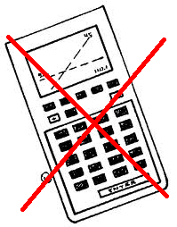
● Full marks will not be awarded if a correct answer is not accompanied by supporting evidence or explanations of how the results or the solutions have been achieved.
● When the answer provided is not the correct one, some marks can be awarded if it is evident that an appropriate method and/or a correct approach has been used.
NUMBER OF EXAM DOCUMENTS: 2
EXAM DOCUMENTS:
EXAM PAPER | YES ⊠ NO ☐
ANSWER BOOKLET | YES ☐ NO ⊠
FORMULA BOOKLET | YES ⊠ NO ☐

NUMBER OF PAGES OF THE EXAM PAPER: 6

REMINDER: NO ANSWERS TO BE WRITTEN ON THE EXAM PAPER

NAME OF TEACHERS: M.A. COSTA MOLINA, A. FIELDING, K. HANSEN, A. HARSANYI, C. PETRUZ, O. PICAUD, R. SOUISSI, I. STEPIEN-MOSKALIK, L. WURZER.

NAME OF PUPIL: …………………………………

PART A
 |  |  | Page 1/4 | Marks
1) | The diagram shows the graph of the derivative $f'$ of a function $f$.
 | 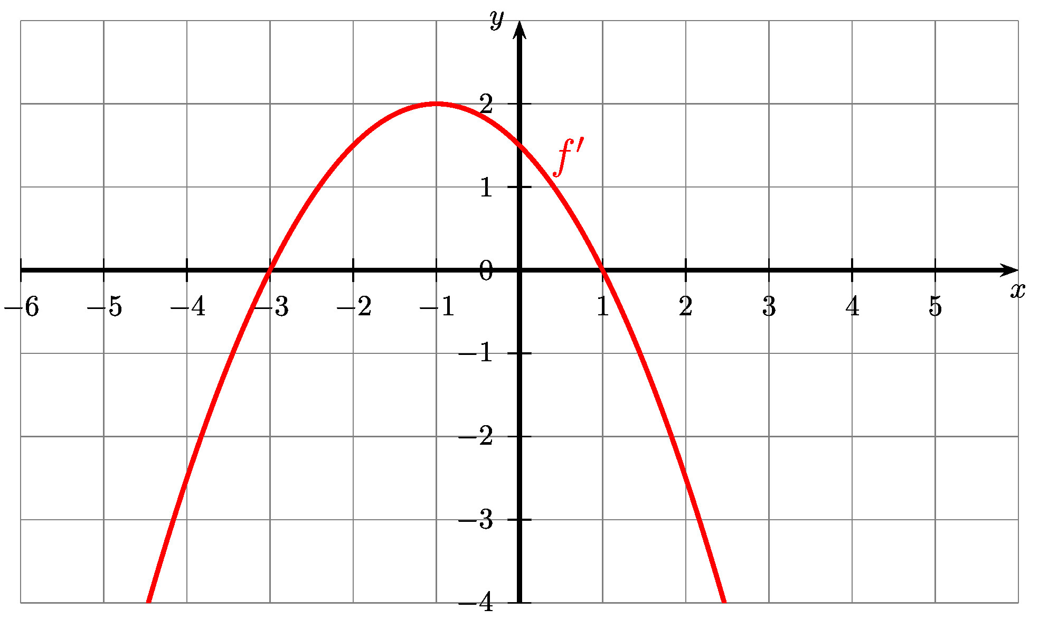
 | a) Give the intervals on which the function $f$ is decreasing and those on which the function $f$ is increasing.  b) Determine whether the function $f$ has extremums. If yes, determine their nature. Justify your answers. |  |  | 5 marks
2) | Consider the function $f$ defined by $f\left(x\right)=x^{2}−7x+3$.
 | Find the primitive $F$ of $f$ given that $F\left(2\right)=5$. |  |  | 5 marks
3) | It is a very hot summer, so Jim is digging a hole in the garden for a pool. Today it’s raining so he is sitting inside and wonder how deep the hole is already. He knows that it needs to be at least 2 meters deep. He knows that the hole can be described as the following function:
 | $$f\left(x\right)=x^{2}−3x$$ | 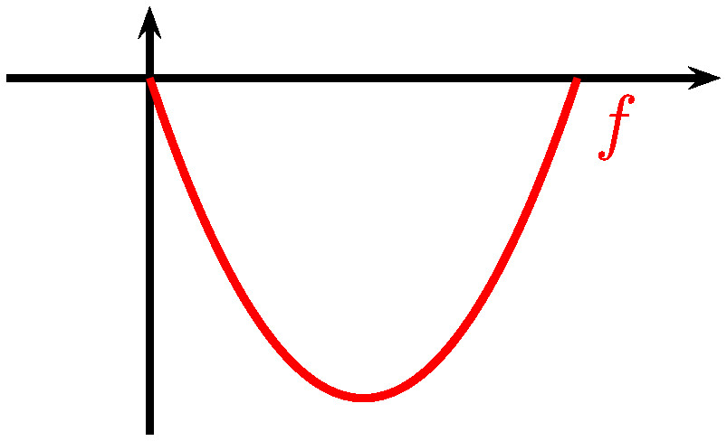
 | Determine if the hole is deep enough. Justify your answer by calculating how deep he already has been digging. |  |  | 5 marks

PART A
 |  | Page 2/4 | Marks
4) | The diagram shows the graphs of a function $f$ and of its derivative $f'$.
 | 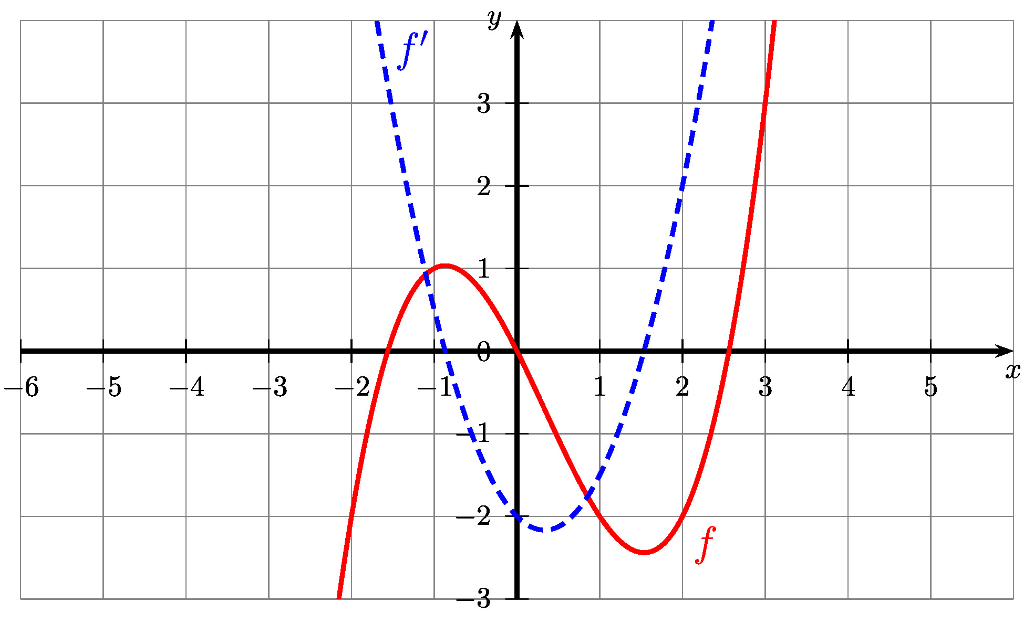
 | a) Determine $f\left(2\right)$ and $f'\left(2\right)$.  b) Determine an equation of the tangent to the graph of $f$ at the point  where $x=2$. |  | 5 marks
5) | In the following, three function equations (with $a$ and $b$ being positive real numbers) and the graphs of five real functions are shown.
 | $f\left(x\right)=a⋅b^{x}$ with $b>1$ $$g\left(x\right)=a⋅x+b$$ $$h\left(x\right)=a⋅sin\left(b⋅x\right)$$
A |  |  | B |  |  | C
D |  |  | E

 | a) Assign the appropriate graph (from A to E) to each of the three function equations (from $f$ to $h$).  b) For the two remaining function graphs, state which model each represents. |  | 5 marks

PART A
 |  | Page 3/4 | Marks
6) | In 2007, almost no one owned a smartphone. In 2017, they are seemingly everywhere. Globally, among people aged 18-35, nearly 2 in every 3 people own a smartphone. The graph below shows the number of smartphones sold each year, from 2007, in millions.
 | 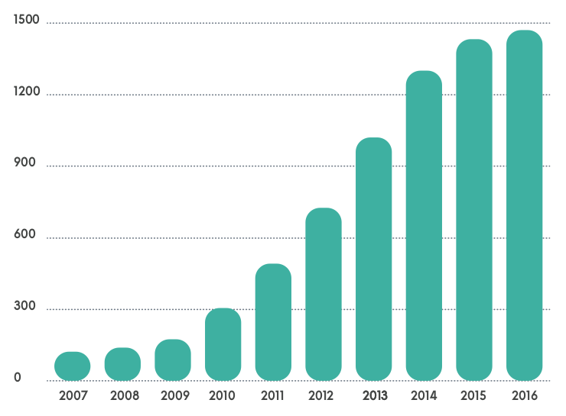
 | a) Between 2009 and 2013, give the model would you use to describe the evolution of the number of smarpthones sold.  b) Starting from 2014, the previous model is not valid anymore. Explain a possible reason that explains this. |  | 5 marks
7) | In the cafeteria, they sell sandwiches. 3/4 of people choose chicken, the rest choose tuna sandwich.
 | What is the probability of selling exactly 2 chicken sandwiches to the next 3 customers? |  | 5 marks
8) | The probability that a man is at the supermarket because his wife sent him is 2/3.  The probability that a man sent by his wife to the supermarket has the necessary coin for the trolley is 1/5.  The probability that a man that is at the supermarket not sent by his wife has the coin for the trolley is 3/5.
 | a) Give the tree diagram of the situation described above.  b) A man has the coin for the trolley. Compute the probability that he has been sent to the supermarket by his wife. |  | 5 marks

PART A
 |  | Page 4/4 | Marks
9) | Three scatter diagrams can be seen in the figures below:
 | 1 2 3
 | Match each of them (1, 2, 3) with the most appropriate statement (a, b, c) and explain your answers.  a. We graphed a man’s age and the number of hairs on his head.  b. We graphed a woman’s shoe size and the length of her hair.  c. We graphed a person’s eating and weight gain. |  | 5 marks
10) | It is assumed that the better children master their first language (mother tongue), the more successful they will be in their second language.  In a preschool group, 12 bilingual children were tested in their mother tongue and their second language. The maximum score for each test was 20 points. The results of the two tests are shown in the tables below:
 | Points First Language | 5 | 9 | 12 | 13 | 15 | 16 | 18 | 19 | 20
 | Points Second Language | 5 | 5 | 5 | 8 | 5.5 | 9.5 | 13 | 19 | 20

 | a) Draw a scatter diagram using the data from the table. The points of the first language is the independent variable and the points in the second language is the dependent variable.  b) The linear correlation coefficient is $r=0.84$. Interpret the relationship between the two variables in this context using this correlation coefficient.  c) We decide to use an exponential regression. Draw on the graph of question a) the graph of an exponential function that fits these results. |  | 5 marks

END OF THE EXAMINATION

