MATHEMATICS 3 PERIODS
PART B

DATE: Monday 30th January 2023
DURATION OF THE EXAMINATION:  2 hours (120 minutes)  AUTHORISED MATERIAL:  ● Examination with technological tool: Calculator Casio Graph 90+E, Numworks or TI-83 Premium CE Python in exam mode.  ● Pencil for the graphs  ● Formula booklet  SPECIFIC INSTRUCTIONS: | 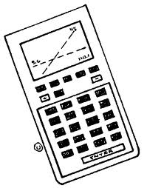
● Answers must show the reasoning behind the results or solutions provided.
● Full marks will not be awarded if a correct answer is not accompanied by supporting evidence or explanations of how the results or the solutions have been achieved.
● When the answer provided is not the correct one, some marks can be awarded if it is evident that an appropriate method and/or a correct approach has been used.
NUMBER OF EXAM DOCUMENTS: 2
EXAM DOCUMENTS:
EXAM PAPER | YES ⊠ NO ☐
ANSWER BOOKLET | YES ☐ NO ⊠
FORMULA BOOKLET | YES ⊠ NO ☐

NUMBER OF PAGES OF THE EXAM PAPER: 6

REMINDER: NO ANSWERS TO BE WRITTEN ON THE EXAM PAPER

NOM DES PROFESSEURS : M.A. COSTA MOLINA, A. FIELDING, K. HANSEN, A. HARSANYI, C. PETRUZ, O. PICAUD, R. SOUISSI, I. STEPIEN-MOSKALIK, L. WURZER.

NAME OF PUPIL: …………………………………

PART B
QUESTION B1 |  |  | Page 1/2 | Marks
Dry ice (solid state CO₂) at a certain ambient temperature produces gas that can be easily spotted.
The famous chef Sebastianic intends to use 100 g of dry ice to produce a scenical effect for his last creation, a special dessert In order to understand how the dry ice behave, Sebastianic took several time the weight during sublimation of the sample:
 | Time in min (x) | 2 | 4 | 6 | 8 | 10
 | Dry ice weight in g (y) | 92 | 78 | 62 | 51 | 40

a) | Copy on your paper the correct scatter plot of the data in the table choosing between the red and the blue one of the following diagram: |  |  | 2 marks
 | 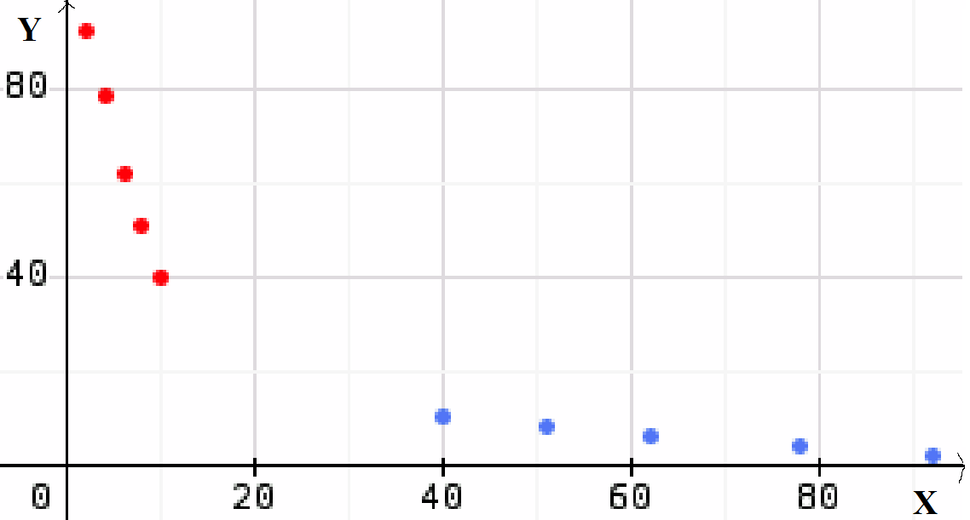
b) | Give the value of the linear correlation coefficient of the data and explain if such a value is indicating or not a linear dependency between the two variables. Explain why the linear correlation coefficient has a negative value. |  |  | 3 marks
c) | Determine an equation in the form $y=m⋅x+b$ of the linear regression of $y$ on $x$ using the data from the table.  Give the numbers $m$ and $b$ correct to two decimal places. |  |  | 3 marks

PART B
QUESTION B1 |  | Page 2/2 | Marks
In questions d) and e), use the model $y=−6.6⋅x+104$.
d) | Use the model to calculate how many grams of dry ice are still present after 13 minutes. Explain if this model has a good prediction for the dry ice weight after 20 minutes. |  | 3 marks
e) | Use the model to calculate when the dry ice is over. |  | 3 marks
The chef Sebastianic is satisfied of the dry ice results and adds to the menu the new dessert. In order to fulfill the demand, he needs to buy some dry ice.
The cost $f\left(x\right)$ per kilogram of dry ice (in euros), $x$ years since the start of the year 2000 (the beginning of year 2000 corresponds to $x=0$), is well described by the function:
$$f\left(x\right)=\left(5+x\right)e^{−0.12x}+3$$
f) | Sebastianic bought 1 kg of dry ice at the beginning of 2023. Determine how much he paid. |  | 2 marks
The derivative function of the function f is
$$f'\left(x\right)=\left(0.4−0.12x\right)e^{−0.12x}$$
The function $f$ has only one stationary point.
g) | Calculate in which year the dry ice cost was the highest and state that cost in euros. |  | 3 marks
h) | State the years when the cost of the dry ice was increasing, and the years when it was decreasing. |  | 3 marks
i) | Calculate the values of $f'\left(8\right)$ and $f'\left(20\right)$ to state the variation rate of the dry ice cost in time, at the beginning of year 2008 and at the beginning of year 2020. Determine on which of those two years the price was lowering more quickly. |  | 3 marks

PART B
QUESTION B2 |  |  | Page 1/2 | Marks
In the first part of this exercise, we study the cooking of an egg that has just been taken out from a refrigerator.

An egg is soft-boiled when its yolk reaches a temperature of exactly 45°C.
In questions a), b) and c), we consider an egg of mass 60 g. The cooking time $f\left(x\right)$ (in seconds) needed to have the yolk of this egg reach the temperature $x$ (in °C) is given by:
$$f\left(x\right)=−16⋅{60}^{2/3}⋅ln\left(\frac{100−x}{192}\right)$$
a) | Determine how long it takes for this egg to be soft-boiled. Round to the nearest second. |  |  | 2 marks
b) | Determine the temperature of the yolk in this egg after it has boiled for 240 seconds. Round to the nearest degree. |  |  | 3 marks
c) | Draw the graph showing the cooking time $f\left(x\right)$ as a function of the temperature $x$ in the yolk for this egg, for temperatures between 4°C to 45°C. |  |  | 4 marks
In question d), we consider an egg that is soft-boiled after a cooking time of 275 seconds. The following equality applies to the mass $m$ (in grams) of this egg:
$$275=−16⋅m^{2/3}⋅ln\left(\frac{55}{192}\right)$$
d) | Determine the mass of this egg. Round to the nearest gram. |  |  | 3 marks

PART B
QUESTION B2 |  | Page 2/2 | Marks
Every morning in a week (7 days), a man is served exactly one egg. Each morning, the probability that the served egg is soft-boiled is $p=0.65$, independently of other mornings.
We study the random variable $X$ defined as the number of soft-boiled eggs this man will be served during those 7 mornings.
e) | Show that $X$ follows a binomial distribution, and give its parameters. |  | 2 marks
f) | Determine the probability that this man was served only one soft-boiled egg during those 7 mornings. |  | 3 marks
g) | Determine the probability that this man was served soft-boiled eggs for at least 2 mornings in that week. |  | 3 marks
h) | We know that this man was served at least two soft-boiled eggs during this week. Determine the probability that he was served exactly three soft-boiled eggs during this week. |  | 2 marks
i) | Determine the expected value and the standard deviation of the variable $X$. Interpret those values in the context. |  | 3 marks

END OF THE EXAMINATION

