PreBAC
Maths 3
ENGLISH Solutions

DATE: January 30, 2023

Total : ………… /50 points

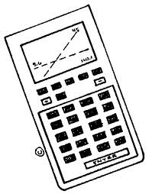
DURATION OF THE EXAMINATION:
2 hours (120 minutes)

EQUIPMENT AUTHORIZES:
Exam without technological support

SPECIFIC INSTRUCTIONS:
- It is essential that the answers be accompanied by the explanations necessary for their preparation.
- Responses should highlight the reasoning that leads to the results or solutions.
- When graphs are used to find a solution, the response should include sketches of them.
- Unless otherwise stated in the question, all points cannot be attributed to a correct answer in the absence of the reasoning and explanations that make it possible to arrive at the results or solutions.
- Where an answer is incorrect, however, part of the points may be awarded when an appropriate method and/or correct approach has been used.

1) | A function is defined by  $f\left(x\right)=k∙x^{2}-2x$ with$k∈R., any real number$  Calculate$k$ , so that $f´\left(1\right)=4$  Solution : $f'(x)=2.k∙x-2$  $$f^{'}\left(1\right)=4 therefore 2.k∙\left(1\right)-2=4$$  $2.k=6$  $$k=3$$ | 5  points
2) | The curves in the diagram are graphs of a function and its derivative. Clearly determine and justify which curve is the function and which is its derivative.$C_{1 }C_{2 }$  Solution: c1 is a quadratic and c2 is a cubic; The cubic C2 has a higher order and so is the function; and C1 is the derivative.  However we must check these 2 are actually linked to each other  The turning points, max/min of C2 have the same x values as the intercepts of c1. The gradient at the turning points is zero so the derivative function should have zeros at this point: hence it is the dervative  The function c2 has a positve slope x<-1 and x>1 it has a negative slope from -1<x<1 This matches when c1 is positive and nagative | 5 points
3) | A function is defined  $$f\left(x\right)=\frac{1}{3}x^{3}-3x^{2}-5x+6$$  Calculate the tangent equation for this function when $x=0$  Solution: $y=mx+c or f\left(x\right)=f^{'}\left(x\right)x$ $f\left(0\right)=\frac{1}{3}{(0)}^{3}-3{(0)}^{2}-5(0)+6$  $$f\left(0\right)=6 y=6$$  $f'(x)=\frac{1}{3}{.3x}^{2}-3.2x-5 f'\left(x\right)=x^{2}-6x-5$  $$f'\left(0\right)={\left(0\right)}^{2}-6(0)-5$$  $f'\left(0\right)=-5$ or$m =-5$  $$y=mx+c or f\left(x\right)=f^{'}\left(x\right)x$$  $$6=-5\left(0\right)+c c=6$$  $$Tangent line is given by: y=-5x+6$$ | 5 points
4) | Match each of the equations (A, B, C , D and E )  with their corresponding graphs (1,2,3,4 and 5),  A:$y=2^{2x}$ B : $y=-2^{x}$ C:$y=\ln{x}$  D:$y=2^{-x+1}$ E:$y=\ln{(x}+2)$  1.) 2.)  3.) 4.)  5.) Solutions: A = 5 B= 2 C= 1 D= 3 E = 4 | 5 points
5) | 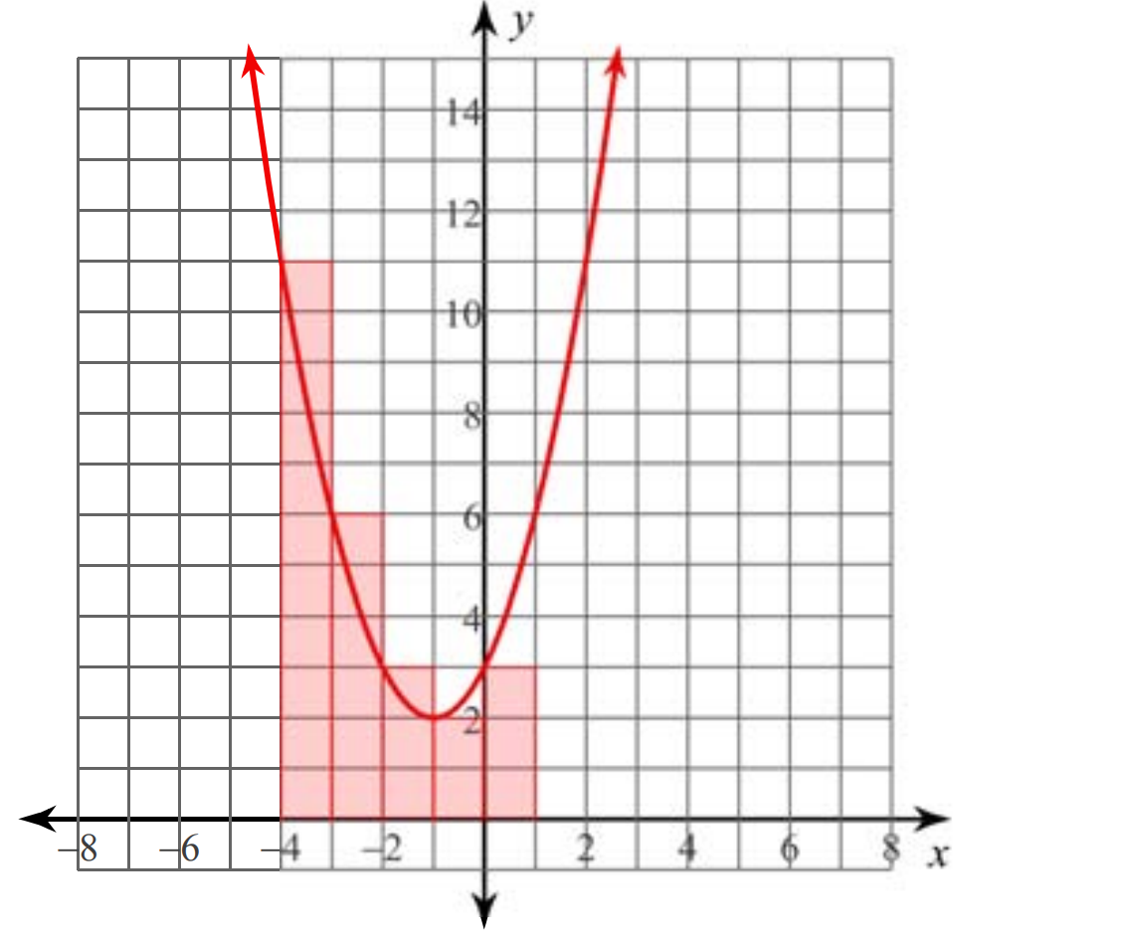  The Graph shows a curve of the function defined by:  $$f\left(x\right)=x^{2}+2x+3$$  A student wants to find an approximation of:  $$\int_{-4}^{1}{f\left(x\right) dx}$$  - Explain, referring to the graph, what this notation means.  - Using the graph, estimate this value by calculating pink rectangles.  - Do you think this estimate is above or below the real value? Explain  Solution :  - The symbol means an integral and to find the value of this integral between the values of –4 < x < 1, this is represented by the total area under the curve bounded by the lines x=-4 and x=1  - Adding the rectangles (11x1)+(6x1)+(3x1)+(2x1)+(3x1)  Integral has the value 25  - This estimate is an over estimate as the area of rectangles above the line of the function is greater than the gaps not calculated under the curve. Approx 2 square units below not added and maybe as much as 4 squares over the line. | 5 points
6) | Marc and Jeff play 4 tennis matches against each other.  The probability of Marc winning a match is $\frac{1}{3} .$  The results of each match are independent.  Calculate the probability that Marc will win exactly one of the 4 matches.  Solution Probability of Marc winning is$\frac{1}{3}$ and Marc loosing is $\frac{2}{3}$  X is the probability of Marc winning  Using the formula $P\left(X=k\right)= \left({n \atop k}\right)p^{k}{(1-p)}^{n-k}$ n=4 k =1  $$P(X=1)=\frac{4!}{3!1!}.{\left(\frac{1}{3}\right)}^{1}{\left(\frac{2}{3}\right)}^{3}$$  $$P(X=1)=4\left(\frac{1}{3}\right)\left(\frac{8}{27}\right)$$  P that Marc wins exactly one match is $\frac{32}{81}$ | 5 points
7) | A survey of 80 S7 students about their choice of subject options showed that:  - 20 chose physics.  - 33 chose economics.  - 41 chose neither physics nor economics.  a) Plot the results of this survey using a Venn diagram or a double-entry table.  b) How many students chose physics or economics?  (c) A student is interviewed at random. Knowing that he chose physics, what is the probability that he also chose economics?  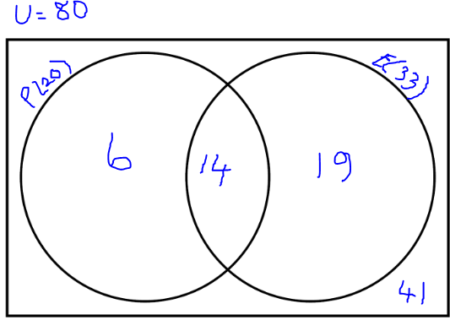  Solution :P = Physics students E= Economics students  Subject Studied Economics Not Economics Totals  Physics 14 6 20  Not Physics 19 41 60  33 47 80  B) 80-41 = 39 So 39 Students choose physics or Economics  (should not be 25 as includes students who do both E and P)  C) 20 students chose physics and of those 14 do Economics  Therefore Probability of doing Economics; given that they student is taking physics is $\frac{14}{20}$ or $\frac{7}{10}$ 0.7 or 70% | 5 points
8) | During the International Kite Festival, a stand organizes a contest to win a kite.  There are 10 cards face down on the table, 7 are red and 3 are black.  There is a six-sided die to roll.  You win if you choose a red card and throw a 5.  or if you choose a black card and throw an even number.  - Justify, by calculations , with which of these two possibilities one has the greatest probability of winning.  - Determine the total probability of winning the kite  Solution :  Probability of choosing a red card is $\frac{7}{10}$  Probability of rolling a 5 is$\frac{1}{6}$  Probability of choosing a red and rolling a 5 is $\frac{7}{10} . \frac{1}{6}$ =$\frac{7}{60}$  Probability of choosing a black is $\frac{3}{10}$  Probability of rolling an even number is $\frac{3}{6}$ or $\frac{1}{2}$  Probability of choosing black and rolling even is $\frac{9}{60}$  $\frac{9}{60}>\frac{7}{60}$ So black card and even die number is more likely than Red card and 5 on the die  B) The probability of winning is sum of 2 probabilities calculated above:  $\frac{9}{60}+\frac{7}{60}$=$\frac{16}{60}$ or $\frac{4}{15}$ | 5 points
9) | 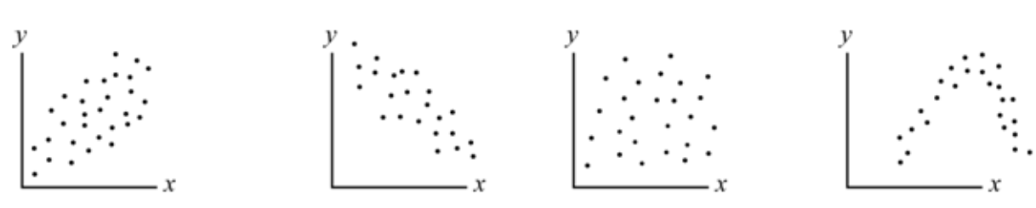  A B C D  - Explain for which figure(s), from A B C and D, it would be appropriate to model the situation as a linear correlation.  - Explain whether scatterplot B has a positive or negative correlation coefficient r.  - Copy the illustrated coordinate system below and draw a simple scatterplot  (at least 5 points) such that the relationship would be considered a linear correlation with the correlation coefficient r≈1.  Solutions  - A and B can be modelled appropriately by linear ;  C has no real correlation and D is not linear – a curve  - B is negative as the slope of the line through the points would have a negative gradient, it is decreasing  - Any 5 points where you can almost perfectly draw a straight line through the points  A best fit line was not asked for just a scatter plot. | 5 points
10) | The number of Ladybirds N(t) living on a rose bush in June is given by the model:  N(t) = 6$.e^{\ln\left(1.16\right).t}$  Where t is the number of days, and t = 0 is on June 1st.  - How many ladybirds were there on the bush on June 1st?  - Rewrite the equation as:  N(t) = a.$b^{t}$  The number of greenfly G(t) on the same rose bush is modelled by the following equation:  G(t)=1500. (${0.68}^{t}$ )  - Is the greenfly population increasing or decreasing?  - Give this change as a percentage change per day.  Solution  - On June first t= 0 therefore N(0) = 6$.e^{\ln\left(1.16\right).0}$  As $e^{.0}=1$ N(0)=6  - N(t) =( 6$).({1.16)}^{t}$ N(t) =( 6$)×({1.16)}^{t}$  - The population of Greenfly is decreasing as the b value is less than 1  - 0.68 represents a decrease of 32% in the number of greenfly per day on the rose bush.  (1-0.68 = 0.32) | 5 points

