MATHEMATICS 3 PERIODS
PART B
ENGLISH version

DATE: Monday 30th January 2023,

Total :………… / 50 points

EXAM DURATION: 2 hours (120 minutes)
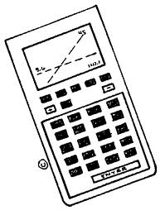
AUTHORISED EQUIPMENT:

Exam with technological support:
Calculator allowed
Pencil for graphics

SPECIAL NOTES:
- It is essential that the answers be accompanied by the explanations necessary for their preparation.
- Responses should highlight the reasoning that leads to the results or solutions.
- When graphs are used to find a solution, the answer should include sketches of them.
- Unless otherwise stated in the question, all points cannot be attributed to a correct answer in the absence of the reasoning and explanations that lead to the results or solutions.
- Where an answer is incorrect, however, part of the points may be awarded when an appropriate method and/or correct approach has been used.

PART B Question 1 : 22 points | Points
a) E. coli bacteria are usually found in the lower intestines of humans and other warm-blooded organisms. They reproduce at a rate of 3.5% per minute.  Scientists observe a colony of 100 000 bacteria at the beginning of the experiment.  Write the equations which would model the growth of E. coli bacteria in the form:  $f\left(t\right)=a∙b^{t}$  represents $f\left(t\right)$ the number of bacteria at a certain time t and t represents time in minutes.  Solution  $f\left(t\right)=100 000∙{1.035}^{t}$  b) Bifidobacterium is the most common bacterium in the gut microbiome of infants. Some bifidobacteria are used as probiotics. We know from previous studies that a colony of bifidobacteria grows in the following pattern:  $$g\left(t\right)=200 000∙{1,05}^{t}$$  $g(t)$ represents the number of bacteria at a certain time $t$  $t$ represents time in minutes.  - Calculate the number of bifidobacteria when $t$= 0 and $t$= 30 to the nearest unit.  $g\left(0\right)=200 000∙{1.05}^{0}$ = 200 000 There are 200 000 bacteria at the start  $g\left(30\right)=200 000∙{1.05}^{30}$=864 388 There are 864 388 bacteria after 30 minutes  - Copy and complete this table and plot graph g for 0≤ $t$ ≤5 in an appropriate coordinate system.  $$t$$ 0 1 2 3 4 5  $$g\left(t\right)$$ 200 000 210 000 220 500 231 525 243 101 255 256  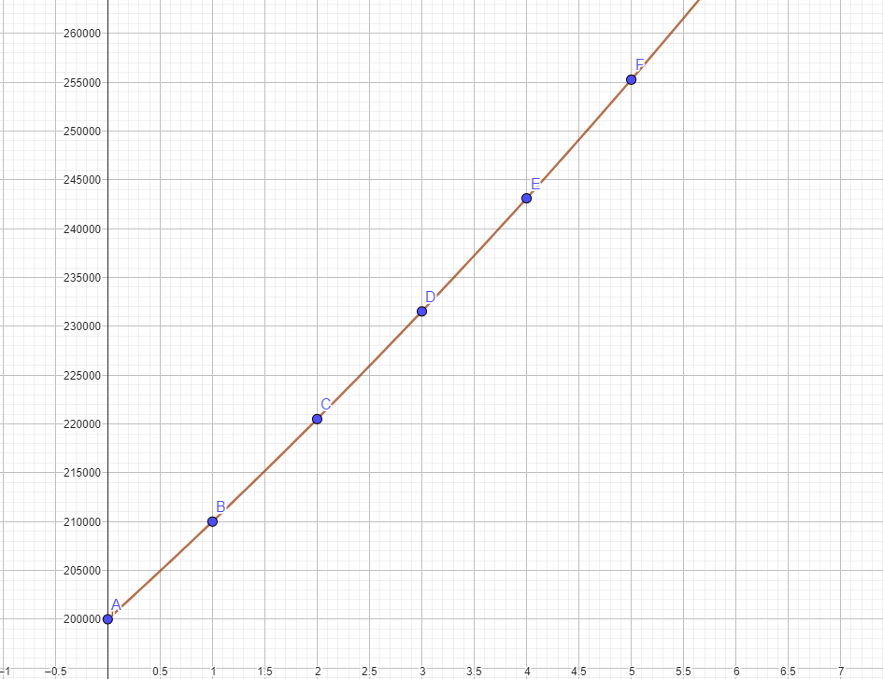  Axis labels ; y = number of bacteria; x = Time in minutes  - The experiment's nutrient solution can only accommodate 10 million bacteria. Calculate when the colony reaches this number. The answer should be rounded to the nearest minute.  Solve $g\left(t\right)=200 000*$ ${1.05}^{t}$  Via logs  $$10 000 000=200 000∙{1.05}^{t}$$  $\frac{10 000 000}{200 000}={1,05}^{t}$  $$50 ={1,05}^{t}$$  $$log50 ={log1.05}^{t} log50 =tlog1.05$$  t = $\frac{log50}{log1.05}$ = 80.18  If logs rounded = 1.699/0.021 = 80.905 ie 81 days  Graphically looking at intersection of y=10 000 000  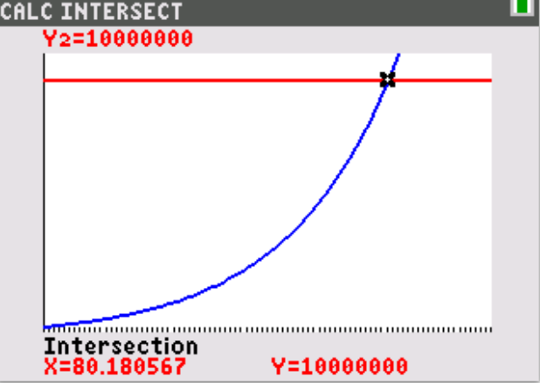  The population of bacteria reaches 10 000 000 after 80 minutes  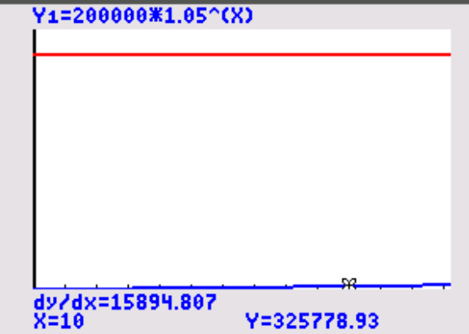  - Calculate the growth rate g'(10) rounded to the integer and interpret the result in the context of the exercise.  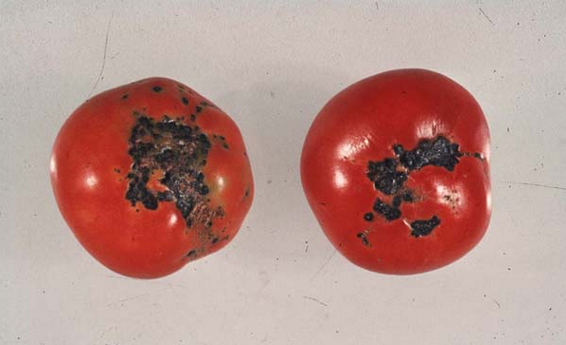  After 10 minutes the bacteria population is growing at a rate of 15 895 bacteria per minute  c)  Bacterial disease of tomato fruit spots is caused by the bacterium Xanthomonas vesicatoria.  The infection causes brown spots on leaves and fruits and can lead to significant yield losses.  We know from experience that the probability of a tomato plant being infected with the bacteria is 2.5%.  A farmer owns a small field with 500 tomato plants.  - Indicate how many infected plants are expected to be found.  Solution 500 x 0.025 = 12.5  We would expect to find 13 infected plants.  - Calculate the probability that only 2% of tomato plants will be infected.  2% of plants is 500x0.02 =10  Binomial Pdf n= 500, p = 0.025 X = 10  $$P(X=10)=\left({500 \atop 10}\right){(0.025)}^{10}{(1-0.025)}^{490}$$  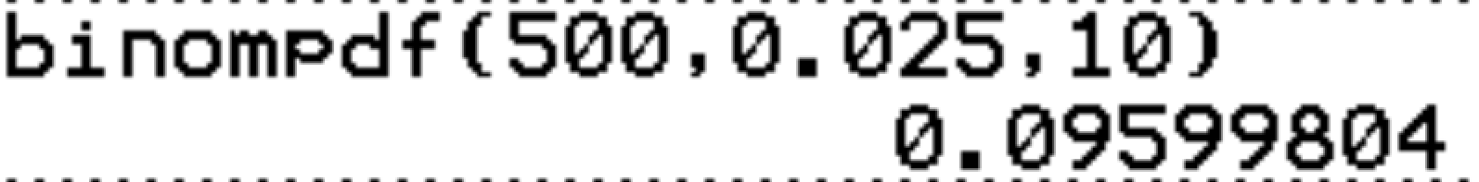  - Calculate the probability that between 10 and 20 plants (including both numbers) will be infected.  Proabability of between 10 and 20  Binomial Cdf X=20 – Binomial Cdf X=9  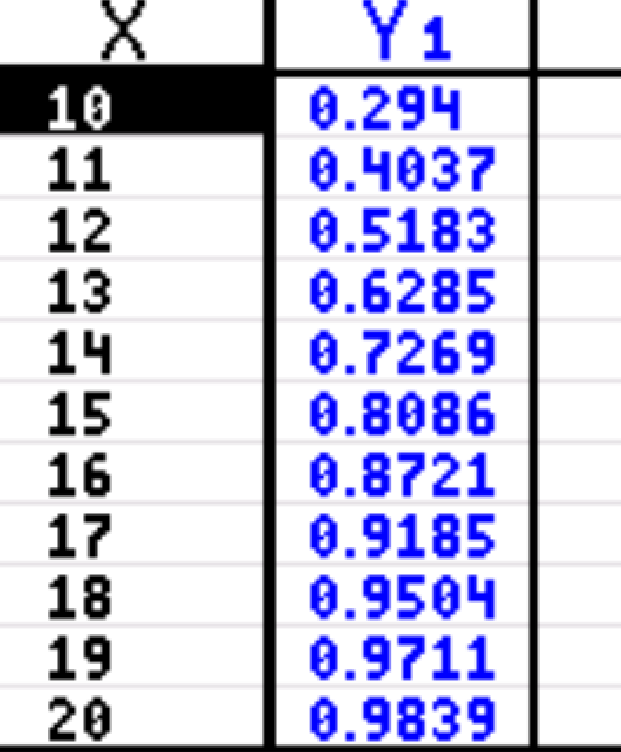  P (10≤X≤20) = 0.9839 – 0.198  = 0.7859  Or method 2  Binomial Pdf add values of 10 through 20 = 0.786  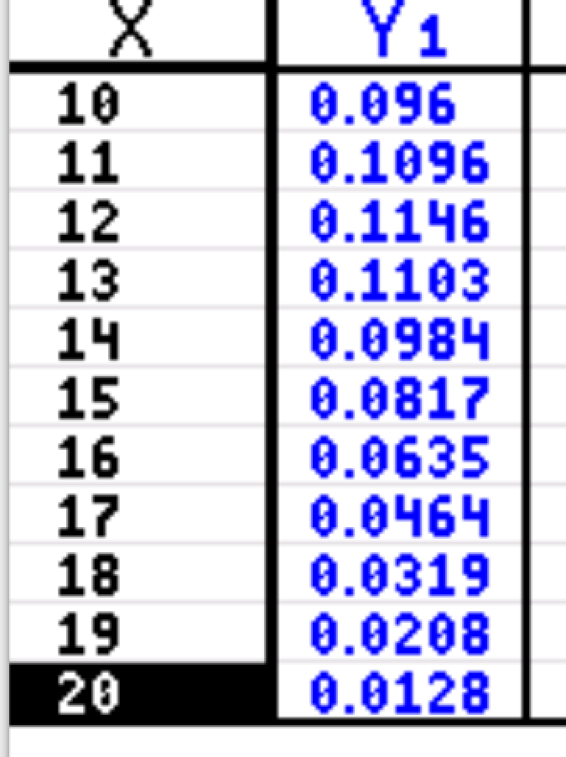 | /2  /4  (no unit -1)  /4  2 table,  2 graph  /2  /3  /2  /2  /3

PART B Question 2 : 28 points | Points
The Town of Mickey-Town evaluates speeding data on local roads in relation to the number of educational radar signs installed. The following table shows the number of signs installed and speeding fines over the past six years:  number of educational radar signs ($x$) 2 3 6 10 12 13  number of speeding fines ($y$) 425 406 375 320 292 275  a) Plot the table data in a scatterplot:  (Suggested scale on the $x$ axis use 1 cm for a sign and on the $y$ axis 1 cm for 20 fines starting the scale from 180).  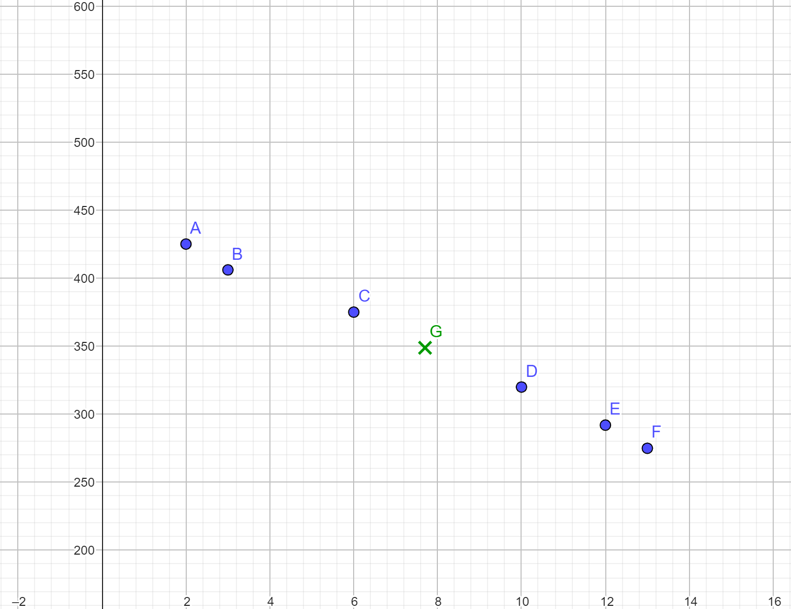  b) Calculate the mean value $\overline{x}$ of the number of signs over the six years.  Round to one decimal place  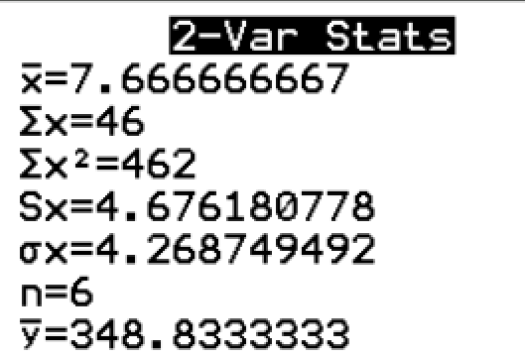 Average number of signs x = 7.7 over the 6 year period  (c) Calculate the mean value $\overline{y}$ of the number of fines. Round to one decimal place  Average number of fine Y over the 6 years is 348.8  d) Draw the mean point ( $\overline{x}$ , $\overline{y}$ ) onto the graph and label it. (see graph above pt G)  (e) Give the values of σx and σy Round to one decimal place  Standard deviation of x is 4.3 and of y is 56.7  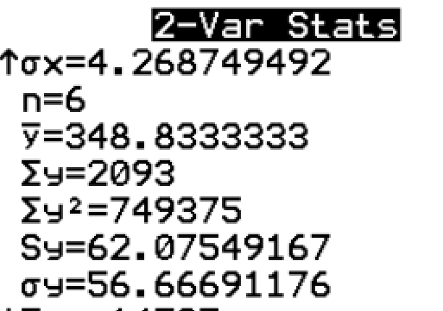  f) Calculate the linear correlation coefficient and explain whether a linear model  is appropriate or not.  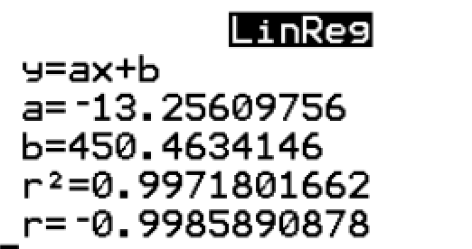 r= -0.9985 which suggests a very strong negative linear correlation, so yes the linear model is appropriate  g) Determine the equation of the line corresponding to the linear correlation fit. Using the  least squares regression method.  In the form $y=ax+b$  Round the values of a and b to 2 decimal places.  y= -13.26 +450.46  h) The company used the following linear regression equation $y=-13x+450$,  Use this to estimate the number of fines if there were 15 signs.  y = -13(15) +450  y= -195+450  = 255  (i) The profit of the educational radar sign company is represented by the function:  $B\left(x\right)={\frac{x}{3}}^{3 }-16x^{2}+220x , 0≤x≤18$  Where $x$ is given in hundreds of radar signs produced. B is given in euros  - What is the profit for selling 900 radar signs?  If 900 radar x is 9 because (900 /100 = 9)  $B\left(9\right)={\frac{(9)}{3}}^{3 }-16{\left(9\right)}^{2}+220(9)$ = 927 Euro  If they do B(900) correct 1 mark - 230 238 000 Euro  - How many radar signs does the company have to sell to make a profit of 800 €?  Solve 800 $={\frac{x}{3}}^{3 }-16x^{2}+220x$ do this by looking at the intersection of the line y =800 and the function  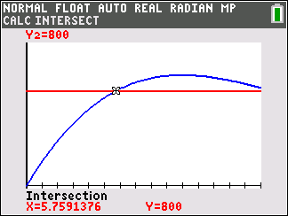  The company must sell 576 radar to make 800 euro in profit  - What is the maximum profit the company can make?  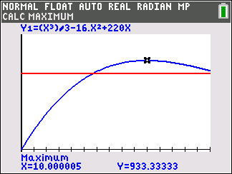  The maximum profit is 933.33 euro  Found value for X = 18 as maximum range – 720 euro (0.5)  - How many radar signs were made to get this maximum profit?  X= 10.000 (x is in hundreds of units sold so 10 x100)  This is when the number of radar sold is 1 000  (j) A factory produces radars signs.  Each radar sign can have two defects that are called fault a and defect b.  A radar sign is chosen at random.  We note A the event "the radar has the defect a" and B the event "the radar has the  defect b".  It is assumed that these two events are independent and that their probability is P(A)= 0.02 and P(B)=0.01.  The company consider a radar sign is defective when it has at least one of two defects.  - Calculate the probability that the radar sign is not defective.  No defect = 0.98 x 0.99 = 0.9702  - Knowing that the sampled radar sign is defective, calculate the probability that it has both defects.  Knowing that it is defective:  P(defect) = 1- no defect 1-0.9702 = 0.0298  Probability it has both faults = 0.02x0.01 = 0.0002  $\frac{0.0002}{0.0298}$ = 0.00671 | /3  /2  /2  /1  /2  /2  /2  /2  /2  /2  If 5.76 (-0.3)  /2  /2  /2  /2

