Mathematics 3P

SECTION: EN

DATE: 30 January 2023 – 13:25
DURATION OF EXAMINATION: 2 hours (120 minutes)

NUMBER OF PUPILS: 10
AUTHORISED MATERIALS: No calculator

Pupil’s name: _____________________________________ CLASS: 7ENA

Teacher’s name: Mme QUINN-LORD

Marking: 10 Questions each worth 5 points.

Total | /50
Grade

SPECIAL INSTRUCTIONS:

- This test consists of ten compulsory questions.
- Information about the points available for each question is given in the paper.

- Your answers:

  - Must be supported by explanations showing the reasoning behind the results or solutions provided. If graphs are used to find a solution, they must be sketched as part of the answer.

  - Must be given using standard mathematical notation.

- Unless indicated otherwise, full marks will not be awarded if a correct answer is not accompanied by supporting evidence or explanations of how the results or the solutions
have been achieved.
- When the answer provided is not the correct one, some marks may still be awarded if it is shown that an appropriate method and/or a correct approach has been used.
- Write in blue or black permanent ink.

MATHS 3P | EUROPEAN SCHOOL LUXEMBOURG I | PREBAC 2023
30 January 2023 | Teacher: Mme QUINN-LORD
PART A: TEST WITHOUT CALCULATOR.
 | Question | Mark
A1 | A cake is taken out of an oven and cools down in a kitchen which has an ambient  temperature of 24°C.  The temperature, $T,$ of the cake, in degrees Celsius, $t$ minutes after it has been  taken out of the oven can be modelled as:  $$T\left(t\right)=24+200⋅e^{\ln{(0.5)∙t}}$$  a) Calculate the temperature of the cake immediately after it was taken out of  the oven.  b) Calculate the temperature of the cake 2 minutes after it was taken out of the  oven.  c) Determine the temperature of the cake in the long run, justifiying your answer. | 1  2  2
A2 | Consider the function $f\left(x\right)=ln⁡(x)$.  a) Determine the domain and range of the function.  b) Determine the coordinate of the point on the graph of y = $f\left(x\right)$ such that the  tangent to the curve is parallel to the line $y=3x-2$.  c) Order the following expressions from smallest to biggest:  $$\ln{1, \ln{e^{2}, e^{0}, }}- ln{e}$$ | 2  2  1
A3 | As part of their leaving school celebrations, a group of S7 students from a  European School go camping.  Their tent door is in the shape of a parabola with height, f (x), and width, x, and  can be modelled as:  $$f\left(x\right)=-\frac{3}{2}x^{2}+\frac{3}{2}$$  Both the height, f (x), and width, x, of the tent door are, given, in metres.  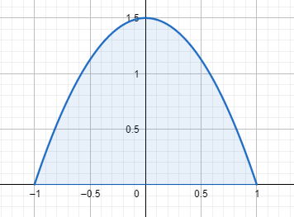  The graph of y = f (x) is shown.  Show that the area of the tent door  is 2 m². | 5
A4 | Consider F ($x$) the primitive of the function $f\left(x\right):$  $F\left(x\right)=\frac{1}{4}x^{4}+2$  The graph of the function $f(x)$ is shown in the diagram below.  Find the value of $b$ if the shaded area is ${20 units}^{2}.$ b > 1  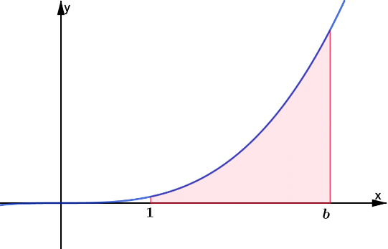 | 5
A5 | From the following set, match each correlation coefficient, $r$, with the scatter plot which you consider, best represents its value. Justify each match you make.  $$\{-0,96; -0,7; -0,4;0,1;0,6; 0,86\}$$  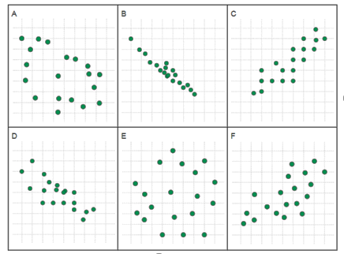 | 5
A6 | BIZBOB 123 LIMITED  BIZBOB 123 manufactures medical and dental supplies.  The scatter diagram, below, shows the cost in pounds and length in days, of  business trips taken by its employees, A through H, over the previous year.  Note: Each of the points A – H on the scatter diagram represents the cost and  length of the corresponding employee’s business trip.  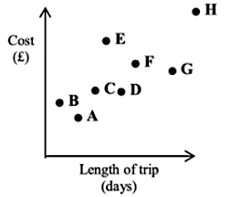  Business trips are usually undertaken by car.  a) One of BIZBOB’s employees took a plane for a business trip. Identify which of  the employees A through H this would be. Explain why you identified this  employee.  BIZBOB 123’s finance wizard states that there is some linear correlation between  the length of a business trip, $L$, and the total associated cost, $C$, that the company  incurs for each trip.  She claims that the equation of the regression line of $C$ on $L$ is:  $$C=a⋅L+b, a,b∈R$$  b) Explain the meaning of the gradient $a$ and the intercept $b.$ Provide an  example, to support each explanation. | 2  3
A7 | Little Tony made a paper aeroplane in art class and decided to check if it could fly.  After climbing a ladder, he threw his paper aeroplane.  The flight path of the paper aeroplane is given as:  $$H\left(t\right)=-\frac{1}{6}t^{3}+t^{2}+2\frac{1}{2}$$  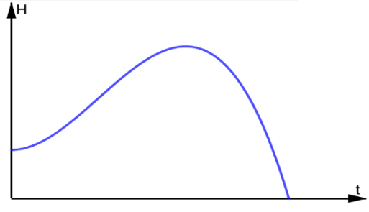  where $H$ is the height of the paper aeroplane, in meters, t seconds, after it was launched.  The flight path of Little Tony’s paper airplane  a) Determine, the time at which the paper aeroplane reaches its highest point.  b) Calculate the maximum height of Tony’s paper aeroplane. | 3  2
A8 | 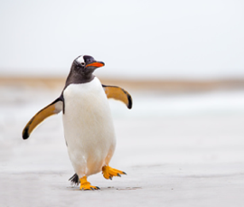  Gentoo penguins live on the Antarctic peninsula  and on numerous surrounding islands.  Scientific studies have determined that the  Antarctic Gentoo penguin population is thriving,  tripling every five years, expanding not only in  size but also in distribution.  A 2021 population assessment estimated that  300,000 penguins were inhabiting the Antarctic  peninsula.  Given:  P (t ) is the size of the Antarctic peninsula penguin population.  t is the time, in years, since the 2021 population assessment.  a) Estimate the size of the 2024 Antarctic Gentoo penguin population, given that  population growth follows a linear model.  Gentoo penguins have an incredible swimming speed; capable of obtaining speeds  of up to 36 km/hour, i.e. 10 metres/second.  Consider the speed-time graph of a Gentoo penguin’s travel.  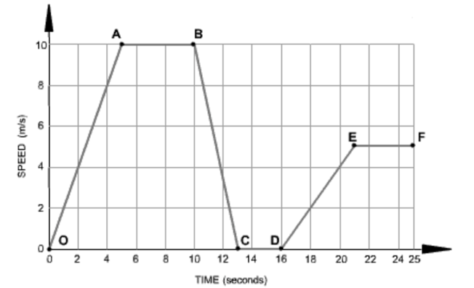  b) Select the appropriate the journey segment(s)  A: From O to A B: From A to B  C: From B to C D: From C to D  E: From D to E F: From E to F  to complete the sentence below.  “The Gentoo penguin is swimming at a constant speed  of 10 m/s for 5 seconds ___________________ and is  accelerating at 1 m/s² ___________________”  Important: Write the complete sentence on your exam script. | 3  2
A9 | One of the best known, and most Instagram able, Australian mammals is the quokka. Found solely on the island of Rottnest, Western Australia, these small marsupials with their smiley faces look like the happiest animals in the world.  A Quokka  A lucky 80% of all tourists encounter a quokka whilst visiting Rottnest Island.  However, on rainy days the likelihood of seeing a quokka is reduced; 9/10th of  tourists who do not encounter quokkas, said that it was raining during their visit to  the island.  Note: Meteorological records indicate it rains, on Rottnest Island, on 30% of  days.  Let Q be the event a tourist, on Rottnest Island, encounters a quokka.  Let R be the event it is rainy day on Rottnest Island.  a) Represent the above information in a two-way, contingency, table.  b) Hence, or otherwise, determine the likelihood that a Rottnest Island tourist is  unlucky given that it is not a rainy day.  Note: A tourist is considered to be unlucky if they do not encounter a  quokka on their trip to the island. | 3  2
A10 | Two brothers are playing darts. The probability that Kevin wins against his older  brother is $\frac{1}{4}$. The brothers play four consecutive games of darts.  Show that the probability that Kevin wins exactly two games is six times greater than him winning both the first and second games and then losing the third and fourth games played. | 5

END OF PART A

