Mathematics 3P

SECTION: EN

DATE: 30th January 2023 – 8.45 a.m.
DURATION OF EXAMINATION: 2 hours (120 minutes)

NUMBER OF PUPILS: 10
AUTHORISED MATERIALS: Graphical calculator non-CAS

Pupil’s name: __________________________________ CLASS: 7ENA

Teacher’s name: Mme QUINN-LORD

Marking: Question B1: 25 points, Question B2: 25 points

Total | /50
Grade

SPECIAL INSTRUCTIONS:

- This test consists of two long compulsory questions, worth 25 points. Each question includes several sub-questions. Information about the points available for each sub-question is given in the paper.
- Use a different examination sheet for each question and clearly label the number of question and sub-questions.
- Your answers

  - Must be supported by explanations showing the reasoning behind the results or solutions provided.

  - Must be given using standard mathematical notation(not that of the calculator)

- Unless indicated otherwise, full marks will not be awarded if a correct answer is not accompanied by supporting evidence or explanations of how the results or the solutions have been achieved.
- When the answer provided is not the correct one, some marks may still be awarded if it is shown that an appropriate method and/or a correct approach has been used.
- Write in blue or black permanent ink and don’t share your calculator with other pupils.

MATHS 3P | EUROPEAN SCHOOL LUXEMBOURG I | PRE BAC 2023
30th January 2023 | Teacher: Mme QUINN-LORD
PART B: TEST WITH CALCULATOR.
Question B1: Oxygen Intake on a Treadmill
A group of athletes volunteered to have their oxygen
intake measured whilst running on a treadmill.
The treadmill allows for adjustments to the incline of the
run and to the speed at which the belt of the treadmill
rotates.
The treadmill’s running power can be adjusted by increasing the speed of the treadmill as well as increasing the incline of
the run.
In the table, below, you will find data for the volunteer athletes’ intake of oxygen, in litres per minute, for different levels of treadmill running power, in Watts.
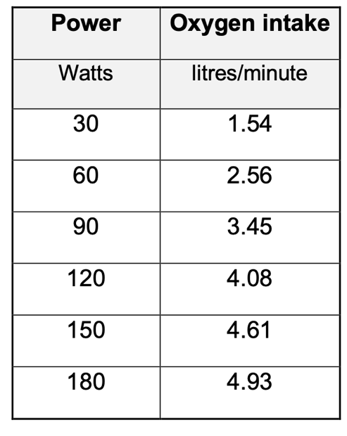

a) |  | Draw a scatter diagram showing oxygen intake, in litres per minute, on the vertical  axis, as a function of power, in Watts, on the horizontal axis.  Scale of Axes: Represent 10 Watts as 0.5 cm on the horizontal axis and  one litre/minute as 1 cm on the vertical axis. | 3
The data can be modelled using a linear function $y=ax+b$ where $y$ is the
oxygen intake and $x$ is the power.
b) |  | Use your calculator to find the equation of the line of regression of $y$ on x, giving  the values of a and b correct to three decimal places. | 2
c) |  | Use the line of regression, from part b) to calculate, correct to two decimal places,  the oxygen intake of an athlete running on a treadmill with a power of 200 Watts.  If you didn't find values for $a$and $b$ in part b) please use $a=$ 0.02 and $b=1$.16 | 2
d) |  | Determine the value of $\overline{x} and$ $\overline{y},$rounding to two decimal places, as  appropriate. Plot the point ($\overline{x}$, $\overline{y}$) on the scatter diagram. | 2
e) |  | Draw the regression line on your scatter plot. Describe the correlation between  oxygen intake and treadmill running power. Explain why you described the  correlation as you did. | 3
Consider the logarithmic model:
$f(x)=1.94∙ln(x)-5.2$
This model could also be used to model the bivariate data set Power, x, and
Oxygen Intake, y.
Below is the graph of the logarithmic function y = $f\left(x\right).$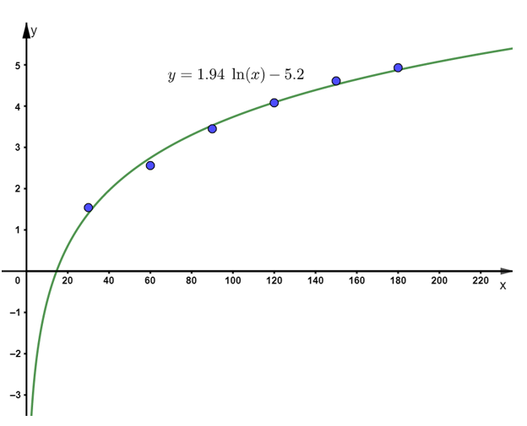

f) |  | Use the logarithmic model to calculate, correct to two decimal places, the oxygen  intake of an athlete when the treadmill’s running power is 100 Watts. | 2
g) |  | Calculate, correct to two decimal places, the value of the derivative of the  logarithmic function when the treadmill’s running power is 100 Watts. | 2
h) |  | Explain the meaning of the value of the derivative calculated in part g). | 2
 |  | An athlete would like to adjust the treadmill’s running power to permit an oxygen intake of exactly 3 litres/minute.
i) |  | Use the logarithmic model to determine, correct one decimal place, the power  level at which the treadmill must be set, to permit an oxygen intake of three  litres/minute. | 2
Both the linear model and the logarithmic model fit well to the given data points. However, when using the models for interpolation or extrapolation, one model
falls short i.e., it is not as appropriate as thought.

j) |  | Select the appropriate word(s) from the list:  Word Choices  A: Linear  B: Logarithmic  C: Interpolation  D: Extrapolation  to complete the sentence below.  “The _______________ model should not be used for ________________.”  Write the entire sentence on your exam script. Provide reasoning for your choice  of word(s). | 2
In the group of volunteer athletes, 60% were football players, 30% were
cross-country runners and 20% of the athletes did neither of these two sports.
k) |  | Given that an athlete plays football, calculate the probability that this athlete isn't a cross-country runner. | 2
l) |  | Out of the 12 Venn diagrams, numbered one through twelve, given below, choose the Venn diagram where the shaded region, matches the probability that you were asked to calculate in the part k). | 1
Question B2: Population Growth in Luxembourg
Luxembourg has experienced steep population growth in recent years.
Back in 2002, Luxembourg had 442,000 inhabitants; twenty years later, this number has increased to
621,000. Note, both population figures are to the nearest thousand.
Luxembourg’s population growth can be modelled using the function:
$$N\left(t\right)=e^{0.017t + 13}$$
where $N(t)$ is the number of inhabitants in Luxembourg after t, the time, in years.
January 1st 2002, is considered when time, t, is equal to zero.
The graph of function, $N\left(t\right),$ is shown below:
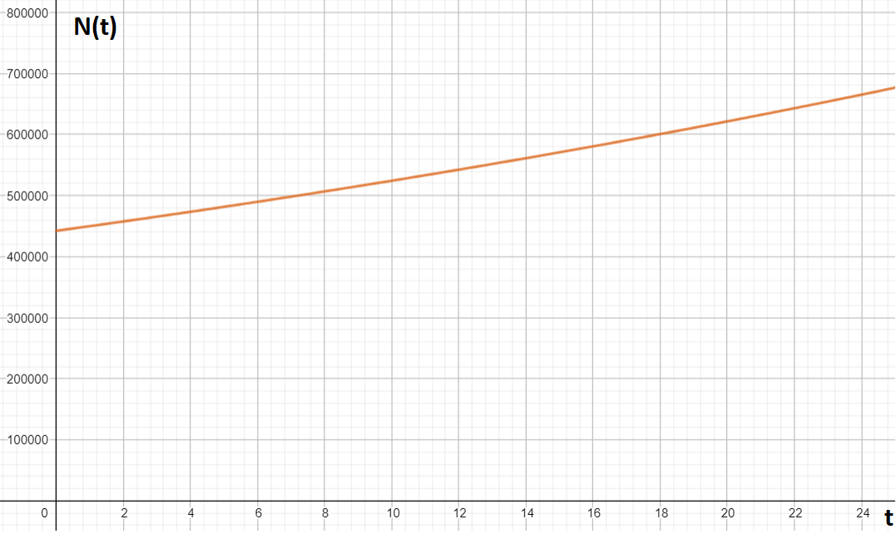

a) | Use the model to calculate the number of inhabitants in Luxembourg in 2012, rounding  to the nearest thousand inhabitants. |  |  | 2
b) | Show that the model can be rewritten as:  $N\left(t\right)=442,413⋅{1.017}^{t}$ |  |  | 3
c) | Use the model in part b) to find the yearly growth rate of Luxembourg’s population,  giving your answer as a percentage. |  |  | 2
 | The derivative of $N(t)$ is $N’\left(t\right)=0.017⋅e^{0.017t + 13}$
d) | Use this derivative to calculate the following integral:  $\int_{0}^{20}{N^{'}\left(t\right)dt}$  Round your answer to nearest whole number. Explain what the result means in terms  of Luxembourg’s population growth. |  |  | 3
e) | The given model is not flawless; explain why this model should not be used in the long  run. |  |  | 1
A second model for population growth in Luxembourg is:
$$N_{2}\left(t\right)=\frac{800,000}{0.8+{0.96}^{t}}$$

f) | Using the second model, determine the size of the Luxembourgish population in the long  run. |  |  | 2
A rapid increase in population necessitates new infrastructure, such as, a supply of
affordable housing, new hospitals, and schools, as well as, better public transport.
Luxtram, Luxembourg’s tram, a part of Luxembourg’s public transportation system,
started operating in 2018.
On Luxtram’s route from “Lux Expo” to “Lycee Bonneweg”, the tram makes stops at
”Universiteit’ and ‘Coque’. On the “Universiteit” to “Coque” segment of its journey, the
tram takes 20 seconds to get to its full speed of 19 m/s.
The speed-time diagram, below, shows a typical, Luxtram journey between the stops “Universiteit” and “Coque”.
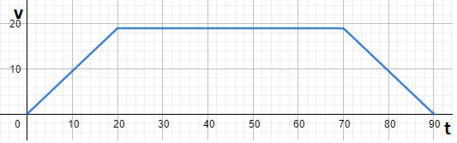

Note, $t$ is the time in seconds and $v$ is the speed in metres per second.
g) | Use the graph, above, to calculate the distance between the stops “Universiteit” and  “Coque”, giving your answer in kilometres. |  |  | 2
If the tram’s full speed were to be 15 m/s, instead of 19 m/s, the speed-time diagram between the stops “Universiteit” and “Coque” would look different to the speed-time diagram shown above.
The distance between the stops remains unchanged.
h) | Select, from the options below, the option which correctly describes the changes to the  speed-time diagram if the tram’s top speed were to be 15 m/s instead of 19 m/s.  Give a reason as to why you selected the option you did.  Option Height of Graph at $v$ = 15 m/s Comparison to the Height when $v$ = 19 m/s Width of Graph at $v$ = 15 m/s Comparison to the Width when $v$ = 19 m/s  A Lower No change  B Lower Narrower  C Lower Wider  D No change Narrower  E No change Wider |  |  | 2
As Luxembourg’s public transport is free; the tram is a popular means of transport for many students. Luxtram knows that, on a usual school day, 1,500 passengers take the
tram, 35%, of whom, are high school students.
Note: Passengers travel independently of each other.
Let X be the number of high school students who take the tram, out of the 1,500 passengers, who take the tram on a usual school day.

i) | Explain why X is binomially distributed, stating the parameters of this binomial  distribution. |  |  | 2
j) | Calculate the expected value and the standard deviation of the number of high school students taking the tram, on a usual school day, rounding to two decimal places where appropriate. |  |  | 2
k) | Calculate, correct to three decimal places, the probability that, on a usual school day, at most 500 high school students use the tram. |  |  | 2
l) | Determine, on a day which is not a usual school day, the total number of passengers  taking the tram, if it were expected that 630 high school students would be taking the  tram. |  |  | 2

END OF PART B

