Mathematics S7MA3

Part A: Examination without technological tool

Date: Tuesday 31st January 2023
Duration: 2 hours (120 minutes)
Course: S7-MA3 EN
Teacher: K. Osborne

Authorised material:

- Formula booklet

Exam without calculator

PART A
 |  | Marks
1 | Consider the function $f\left(x\right)=x^{3}+3x^{2}$.  Determine the equation of the tangent to the curve at $x=-1$. | 5
2 | The population of a small town increases linearly. In 2012 the population was 5000. Five years later it was found to be 6250.  - Determine a model for the population $P$ as a function of $t$ where $t$ is the time in years after 2012.  - Investigate in which year the population exceeds 7000. | 3  2
3 | A student kicks a ball up into the air. The height of the ball, $h$, in metres, can be modelled by the function  $$h\left(t\right)=-5t^{2}+15t$$  where $h$ is the height in metres and $t$ is the time in seconds after it is kicked.  Determine the maximum height reached by the ball. | 5
4 | The function $F\left(x\right)=\frac{2}{3}x^{3}+2x^{2}+2$ is a primitive function of $f\left(x\right)$.  Consider the graph of the function $f\left(x\right)$ shown below.  Show that the shaded area bounded by the graph of $f\left(x\right)$, the lines $x=-1$ and $x=1,$ and the x-axis is equal to $4$ square units.  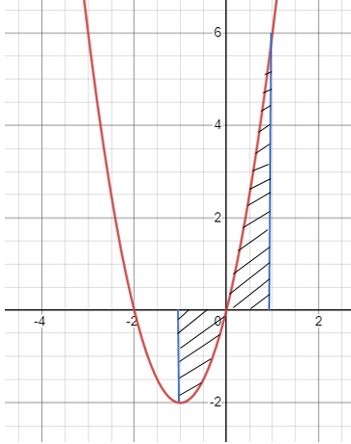 | 5
5 | Scientists observe the population of ladybirds in a field. The population can be modelled by the function $P\left(t\right)=200∙e^{ln⁡(1.015)t}$ where $P$ is the number of ladybirds and $t$ is the time in weeks after the observation starts.  - How many ladybirds are there at the start of the observation?  - Calculate the number of ladybirds after one week.  - Determine the weekly percentage increase. | 1  2  2
6 | An exponential function is of the form $f\left(x\right)=e^{ax+b}$. The graph of $f(x)$ passes through the co-ordinates $\left(0,e\right)$ and $\left(1,\frac{1}{e}\right)$. Determine the parameters $a$ and $b$, and give the function $f\left(x\right).$ | 5
7 | The graph below is the graph of the derivative $f^{'}\left(x\right).$  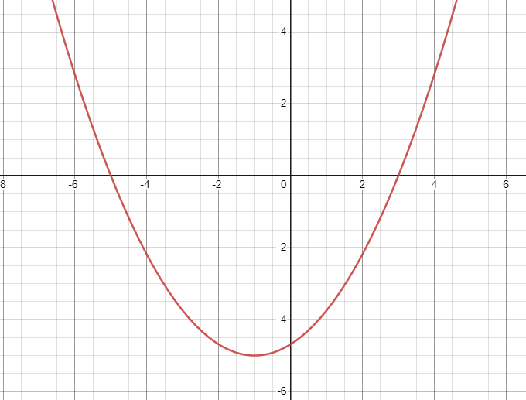  For each of the statements below indicate if it is true or false and give a reason for your answer. Marks will only be given if both the answer and the reason are correct.  $$f'(x)$$  - The function $f\left(x\right)$ has a minimum at $x=-1$.  - The function $f\left(x\right)$ is decreasing over the interval $-5<x<3$.  - The function $f\left(x\right)$ has two turning points.  - The $y$-intercept of the graph of $f\left(x\right)$ cannot be determined from the graph of $f'\left(x\right)$.  - The graph of $f\left(x\right)$ must have two $x$-intercepts. | 5
8 | The graph of a sine function $f(x)$ is shown below.  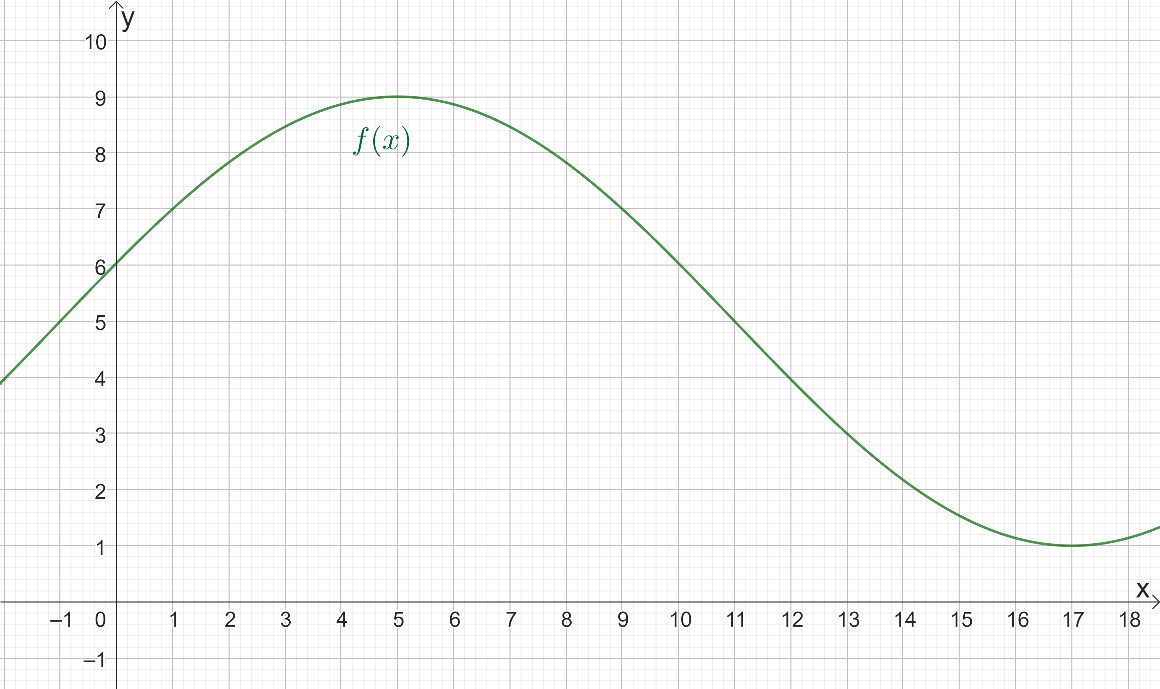  - Determine the period.  - Determine the parameters a, b, c and d in the function  $$f\left(x\right)=a\sin{(b\left(\left(x-c\right)\right)+d}$$ | 1  4
9 | Consider the graph of $f\left(x\right)$ shown below.  Given that $A = 1.37$ and $B = 4.50$, find $\int_{-2}^{1}{f\left(x\right)dx}$.  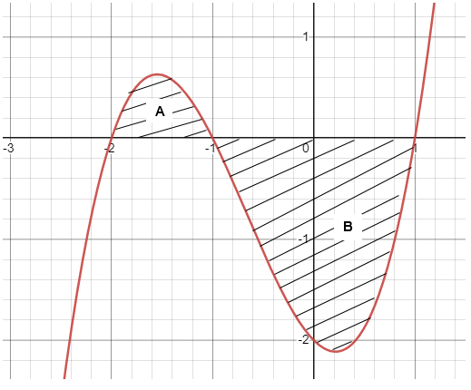 | 5
10 | The acceleration function $a\left(t\right)$ is defined as $a\left(t\right)= v'\left(t\right)$ ,  where $v(t)$ is the velocity function.  The acceleration $a$ (in $m/s^{2}$ ) of an object at a time $t$ (in seconds) can be modelled by the function $a\left(t\right)$. The graph of $a(t)$ is shown below.  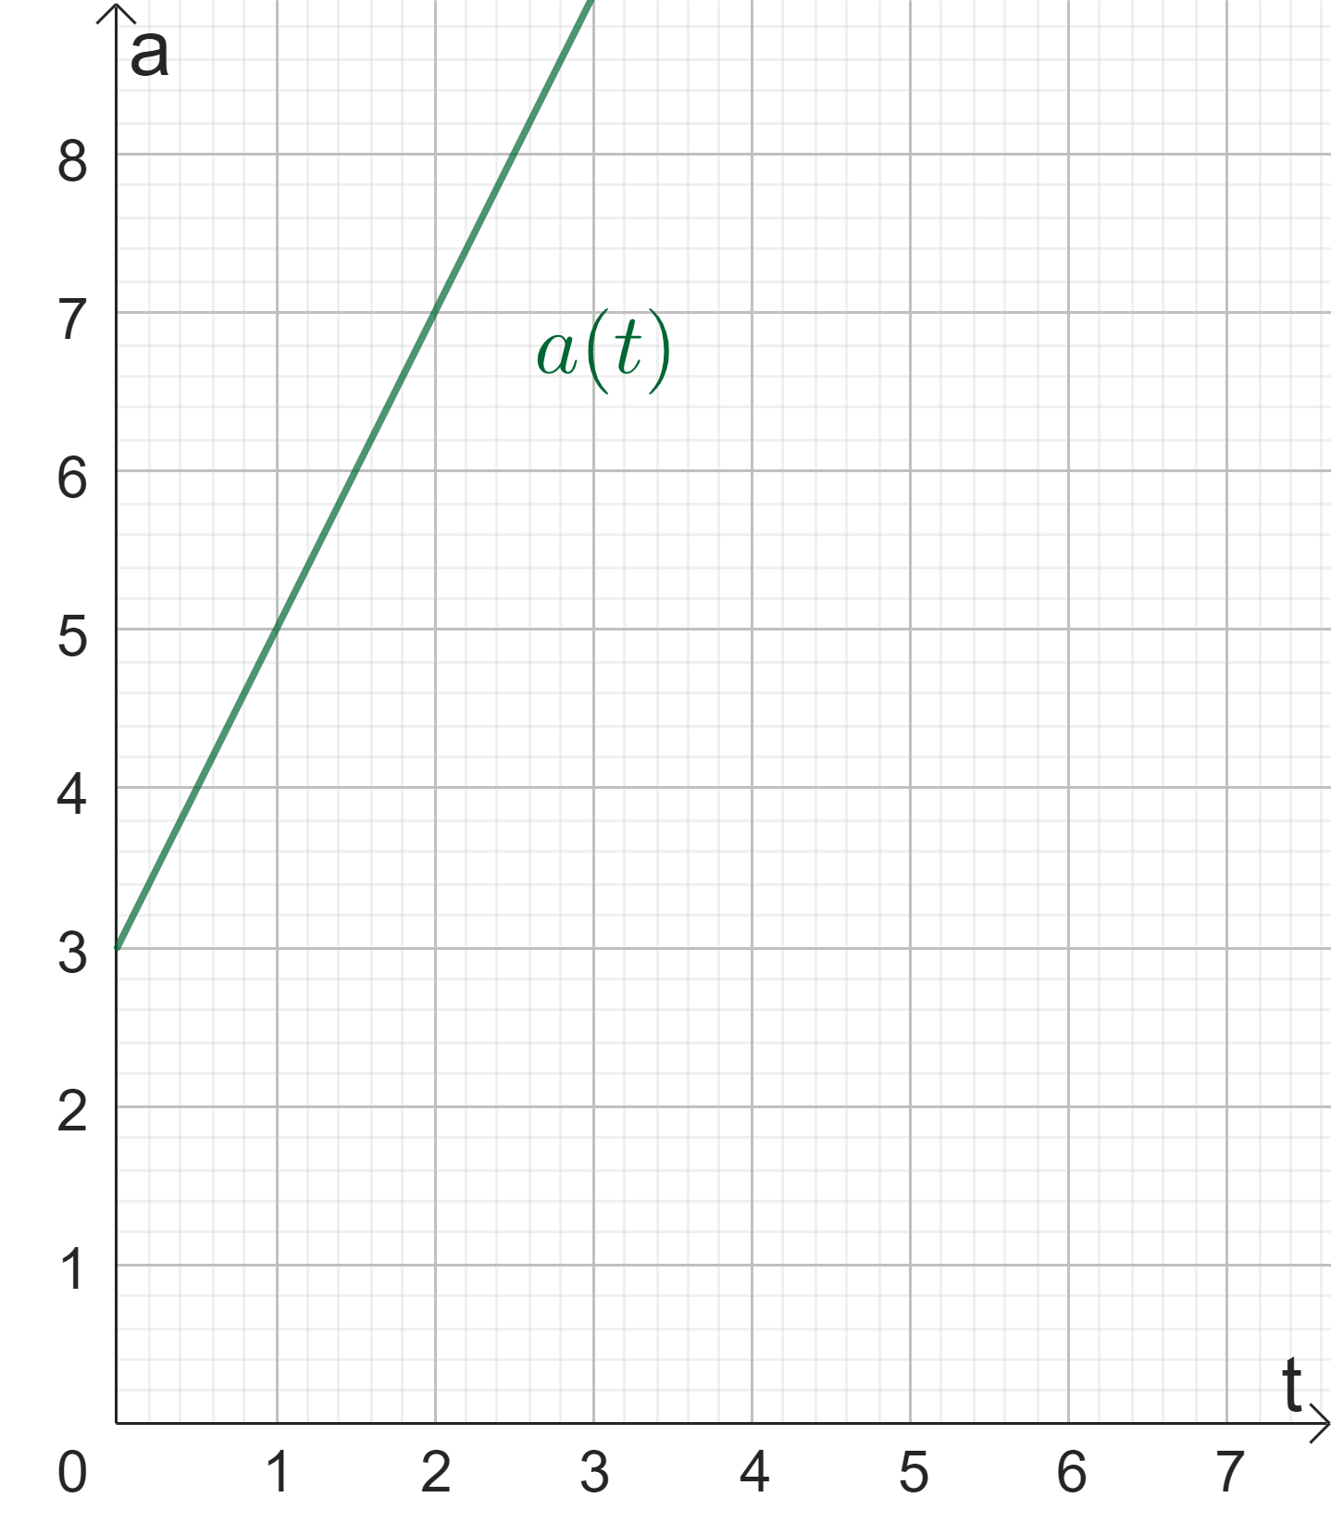  The velocity of the object at $t=0$ is equal to $7 \frac{m}{s}$ .  Calculate the velocity after 2 seconds. | 5

