Mathematics S7MA3

Part B: Examination with technological tool

Date: Tuesday 31st January 2023
Duration: 2 hours (120 minutes)
Course: S7-MA3 EN
Teacher: K. Osborne

Authorised material:

- Formula booklet
- Calculator: Numworks or an alternative calculator, allowed by the school

Exam with calculator

Question B1 | Page 1 of 3 | Marks  (Total:25)
Ski Jump  Part 1 (Parts 1, 2 and 3 of this question can be solved independently.)  The ramp of a ski jump is shown in the diagram below and can be modelled by the function $f\left(x\right)$.  f(x)  A  The function $f(x)$ is defined in the interval shown in the diagram with the equation:  $f\left(x\right)=\frac{3}{10 000}x^{3}-\frac{1}{50}x^{2}-\frac{11}{20}x+70$  , where $f(x)$ and $x$ are expressed in meters.  - Use the equation and the information in the graph to determine the domain of $f(x)$.  - Calculate the area A.  - When a skier is at the end of the ramp, the skis define a tangent line $r$ to the graph of $f(x).$ Define this tangent line and show every step in your calculation.  - The skier is at the lowest point on the ski ramp. Calculate the height at the lowest point on the ski ramp. Explain your method. |  | 2  3  4  4

Question B1 | Page 2 of 3 | Marks
Part 2  Use the following definitions for Parts 2 and 3:  - The position of an object is determined by the function $s\left(t\right),$where t is the time in seconds and s is expressed in meters.  - The velocity function $v(t)$ is defined as $v\left(t\right)=s'(t)$.  - The acceleration function $a(t)$ is defined as $a\left(t\right)=v'(t)$.  After taking off from the ramp, the skier flies through the air until he lands on the ground. The time time between take-off and landing is exactly 3 seconds. The velocity function $v(t)$ (in $m/s$) of the flying skier is shown in the graph below (with $t$ in seconds).  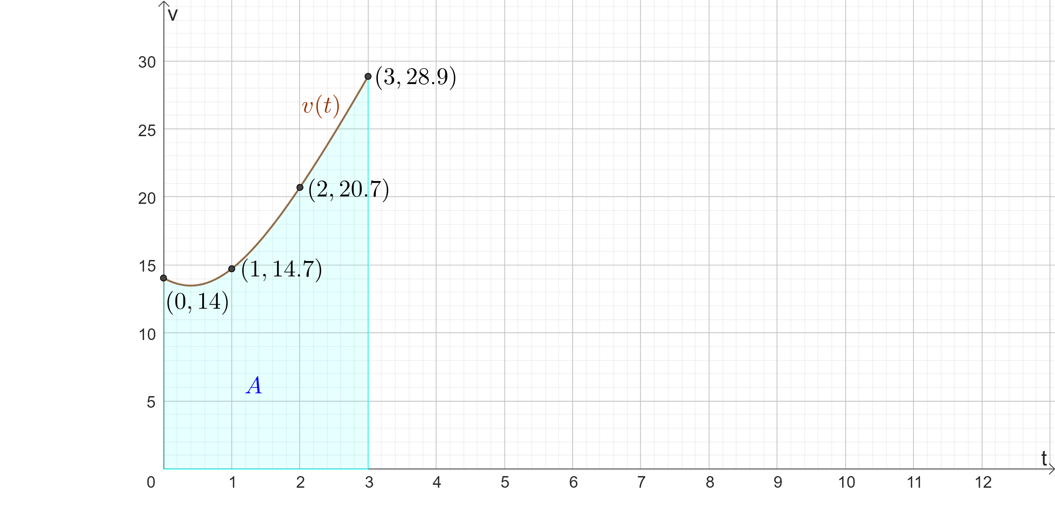  - Find the velocity (in $m/s)$ of the skier when he lands on the ground.  - Use the available information in the diagram to calculate an approximation for the area A. Explain your method.  - Is the approximation for the area A from question f ) an underestimation or an overestimation of the exact area? Justify your answer.  - Interpret what the exact area A means in the given context. |  | 1  3  2  2

Question B1 | Page 3 of 3 | Marks
Part 3  As the skier lands on the landing slope, he slows down until he comes to a complete stop. The velocity of the skier on the landing slope can be modelled by the function:  $v\left(t\right)=-3.4∙t+28.9$  where $t$ is in seconds and $t=0$corresponds to the moment when the skis touch the ground.  - How long does it take for the skier to slow down to a complete stop? Justify your answer.  - Investigate whether a landing slope of 120 m is long enough for the skier. |  | 2  2

Question B2 | Page 1 of 2 | Marks  (Total: 25)
The Island  Part 1 (Parts 1 and 2 of this question can be solved independently.)  The table below gives the measured population on an island.  Beginning of the year 2015 2020  Population 5500 7250  - Use a linear model to predict the population at the beginning of 2023.  - Peter uses an exponential model $p(t)=k{∙a}^{t}$ to model the population. In this model $t=0$ corresponds to the beginning of 2015 and $a$ and $k$ are parameters. Find the parameters $a$ and $k$ of the model $p(t)$.  - Show that the exponential model $f\left(t\right)=5500∙e^{0.05525∙t}$ adequately fits the given data.  For questions d), e) and f), you can use the exponential model  $$f\left(t\right)=5500∙e^{0.05525∙t}$$  In this model $t=0$ corresponds to the beginning of 2015.  - Determine the annual growth rate of the exponential model.  - Calculate $f’(5)$ and interpret what the result means in the given context.  - Use the exponential model to find in which year the population would reach 10000 people.  At the beginning of 2022, the island was hit by an earthquake. Although nobody was hurt in the event, 6000 people decided to leave the island immediately. After they left, the growth rate of the island population was the same as before.  - Investigate in which year the island population will be the same as it was at the beginning of 2015. |  | 2  3  2  2  2  3  3

Question B2 | Page 2 of 2 | Marks
Part 2  The day length is the time between sunrise and sunset. Peter lives on the island and measured the day length of every first day of the month during a whole (non-leap) year. The results are given below:  Date 1st of Jan 1st of Feb 1st of Mar 1st of Apr 1st of May 1st of Jun  Daylength (in hours) 7.67 8.55 10 11.2 12.33 13  Date 1st of Jul 1st of Aug 1st of Sep 1st of Oct 1st of Nov 1st of Dec  Daylength (in hours) 13.05 12.67 11.6 10.35 8.95 7.83  Peter models the day length $h(x)$ with the periodic model  $h\left(x\right)=a∙\sin\left(b\left(x-c\right)\right)+d$ , where $h(x)$ is expressed in hours, $x$ is expressed in days and $x=1$ corresponds to the 1st of January.  - Explain why the day length $h(x)$ can be modelled with a periodic model and give the period of this model.  - Estimate the amplitude of this periodic model.  - Hence, investigate for which values of the parameters $a, b, c,$and $d$ the periodic model $h\left(x\right)$fits the data adequately. |  | 2  2  4

