BACCALAURÉAT EUROPÉEN

MATHEMATICS 5 PERIODS
EXAMPLES OF FINAL ASSESSMENT
FRENCH / ENGLISH
The structure and content of the final assessment is given in the syllabus:
[All] topics from S6 […] could potentially be included.
The final Baccalaureate written exam will consist of two parts, one part with and one part without a technological tool. Each part will make up 50% of the total 100 marks and will be 120 minutes long. All topics from the S6 and S7 5 Period courses can be examined in the final written Baccalaureate exam.
The overall weighting of the competences will be set by the Mathematics BAC matrix. The weightings are designed to ensure meaningful marks across the range of performances. Performances should be distinguishable not only quantitatively (“more or less of the same”) but also qualitatively (“different levels of attainment”). This will make the paper accessible to all pupils while providing more challenging problems to obtain higher marks. […]
The part without the technological tool will consist of six short response questions and two longer questions that require more extended mathematical thinking. These extended questions could be structured, giving pupils greater guidance, or more open, requiring pupils to develop a suitable strategy for solving the problem.
The part with the technological tool will consist of a smaller number of longer, structured questions that allow pupils to explore a given context in more depth. In general, the level of thinking will increase as a pupil works through the questions. The technological tool will need to be used to fully answer this paper, though this does not exclude the possibility that some questions could be fully answered without the use of the tool.
The structure of the papers should therefore not be as rigid as it was with the previous syllabus. Questions can cover any subject, in any order, and one question can cover more than one part of the syllabus, as is the case for some questions in these examples.
Sample paper 2 – part B

Question B1 | 12
Gabriella is playing with her remote-controlled toy car. The following equation describes the path of the car:  $$\left(\begin{aligned}x \\ y\end{aligned}\right)=\left(\begin{aligned}16 \\ 1\end{aligned}\right)+t\left(\begin{aligned}−12 \\ 5\end{aligned}\right)$$  The distance units are metres, and the time is in minutes.  - Write down the initial position of the car.  - Calculate the position of the car after 15 seconds.  - Compute the speed of the car.  Grandma is watching Gabriela from point $P\left(−1,−6\right)$  - Find the shortest distance from point $P$ to the path of the car.  The edge of the cliff is at the point $\left(0,\frac{23}{3}\right)$ and Grandma walks in that direction with velocity vector $\left(\begin{aligned}3 \\ 41\end{aligned}\right).$  - After how many minutes will the car reach the edge of the cliff?  - Will Grandma be able to catch the car before it falls down the cliff if she starts moving at the same time as the car? Explain your answer. | 1  1  1  3  2  4

Question B2 | 14
- A contractor must carry out work for a public body. If they do not complete the work on time, they will have to pay a daily penalty: 100 € on the first day, 110 € on the second day, and so on with a daily increase of 10 € a day.  Let $u_{n}$ be the penalty on the $n$-th day. Thus, the first term in sequence $u$ is $u_{1}=100$.  - State the nature and characteristics of sequence $u$.  - Explain why $u_{n}=90+10n$ for all values of integer $n$.  - On what day would the daily penalty amount to 220 €?  - What total amount of penalty would the contractor have paid after 20 days of delay?  - On another construction site, the penalty for delay is 80 euros on the first day and then increases by 10% each day. Let $v_{n}$ be the amount of the penalty on day $n$ in this case.  - Compute the values of the first three terms $v_{1}$, $v_{2}$ and $v_{3}$.  - Explain why $v_{n}=80∙{1.10}^{n−1}$ for all values of integer $n$.  - What is the total amount of penalty the contractor would have paid after 20 days of delay?  - From which day onwards does the amount of the daily penalty in this case exceed that of the first case? | 1  1,5  1  2,5  1,5  1,5  2  3

Question B3 | 11
- On considère les fonctions $x↦cosx$ et $x↦−sinx$ sur $\left[−π;π\right]$ et leurs représentations graphiques ci-dessous :  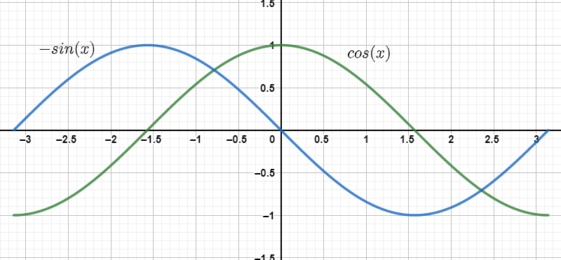  Justifier que les seules solutions de l’équation $cosx+sinx=0$ sur $\left[−π;π\right]$ sont $\frac{−π}{4}$ et $\frac{3π}{4}$.  - Soit $f$ la fonction définie sur $\left[−π;π\right]$ par : $f\left(x\right)=e^{x}∙sinx$  On note $C_{f}$ sa courbe représentative dans un repère.  - Déterminer les variations de la fonction $f$ sur $\left[−π;π\right]$, en précisant l’abscisse, la valeur et la nature de chaque extremum.  - Déterminer une équation de la tangente à la courbe $C_{f}$ au point d’abscisse $\frac{π}{2}$.  - Sur quel intervalle $C_{f}$ est-elle entièrement située au-dessus de chacune de ses tangentes ? Justifier.  - En utilisant deux intégrations par parties successives, calculer la valeur exacte de l’intégrale :  $$\int_{−π}^{π}{f\left(x\right)}dx$$ | 3  2  2  2  2

Question B4 | 13
A company is conducting a study into the relationship between the experience and salary of their staff. The experience and salaries of 12 employees were tabulated.  Experience $x$ (years) 0 2 4 6 8 10 12 14 16 18 20 22  Salary $y$ (€) 4200 4800 4600 5000 5200 5600 5650 5660 5500 6000 5831 6200  - One of the following correlation coefficients fits these data. Which is it?  $r_{1}=0.95,$ $r_{2}=−0.95$ or $r_{3}=1?$  Explain without referring to any computations.  - Compute the coordinates of the average point for these data, to the nearest integer.  - The equation of regression line with the method of the least squares is $y=a+bx,$ where  $b=\frac{\sum_{\overset{˙}{l}=1}^{n}{\left(x_{i}−\overline{x}\right)\left(y_{i}−\overline{y}\right)}}{\sum_{i=1}^{n}{{\left(x_{i}−\overline{x}\right)}^{2}}}$ and $a=\overline{y}−b\overline{x}$.  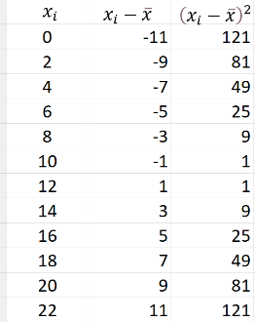  Use the information given below to compute the values of coefficients $a$ and $b$. Give answers to 2 d.p.  $$\sum_{i=1}^{n}{\left(x_{i}−\overline{x}\right)\left(y_{i}−\overline{y}\right)}=45009$$  - Use the linear model $f\left(x\right)=78.7x+4488$ to estimate the salary of an employee with 40 years of experience.  The salaries of the employees of this company are normally distributed with mean $µ=5353$ and standard deviation $σ=553$.  - Mr. Smith, an employee of this company is paid €6459. What proportion of the employees of this Company are paid less that Mr. Smith?  - Compute the probability that an employee’s salary is greater than 7 636 € and comment your question for question 5.  In another company, the salaries are normally distributed with standard deviation $s=620$.  - Knowing that the probability that an employee’s salary is greater than 5000 € is approximately 0.107, find the mean salary in that company. Write your answer to the nearest whole number. | 1  2  2  2  1,5  1,5  3

